C:\Documents and Settings\julia.powell\My Documents\IHO TSMAD\S100-0 main\IHO S-100 Main Oct 1 2007.doc © ISO/IEC 2007 – All rights reservedISO-IEC_ 63Complementary elementIntroductory element — Main elementÉlément introductif — Élément central — Élément complémentaireIntroductory element — Main element — Complementary elementE2007-10-2 ISO/IECISO/IEC 2007 ISO/IEC ISO/IEC _(E). 2Heading 2Heading 1 02 STD Version 2.1c20 4 INLAND ENC HARMONIZATION GROUP

IEHG INLAND ELECTRONIC NAVIGATIONAL CHART
PRODUCT SPECIFICATION

Edition 1.3.0
May 2026

IEHG Publication S-401
Inland Electronic Navigational Chart Product Specification

NOTE: S-401 has various components that are in development.

© Copyright International Hydrographic Organization 2024

Permission N°10/2024
This publication contains material from IHO Publication S-101 which is reproduced with the permission of the International Hydrographic Organization (IHO) Secretariat (Permission N°10/2024) acting for the International Hydrographic Organization (IHO). The IHO does not accept responsibility for the correctness of the material as reproduced, modified and translated by IEHG for S-401. The incorporation of material sourced from IHO shall not be construed as constituting an endorsement by IHO of this publication.”

Contents Page
Introduction 8
1 Overview 9
1.1 Scope 9
1.2 References 9
1.3 Terms, definitions and abbreviations 10
1.3.1 Use of Language 10
1.3.2 Terms and Definitions 10
1.3.3 Abbreviations 16
1.4 S-401 General Data Product Description 17
1.5 Data product specification metadata 17
1.6 IEHG Product Specification Maintenance 18
1.6.1 Introduction 18
1.6.2 New Edition 18
1.6.3 Revision 18
1.6.4 Clarification 18
1.6.5 Version Numbers 19
2 Specification Scopes 19
3 Dataset Identification 19
4 Data Content and structure 21
4.1 Introduction 21
4.2 Application Schema 21
4.3 Feature Catalogue 21
4.3.1 Introduction 21
4.3.2 Feature Types 21
4.3.3 Feature Relationship 21
4.3.4 Information Types 23
4.3.5 Information relationships 23
4.3.6 Attributes 23
4.4 Feature Object Identifier 24
4.5 Dataset 25
4.5.1 Introduction 25
4.5.2 Dataset rules 25
4.5.3 Data Coverage rules 25
4.5.4 Dataset size 27
4.6 Display Scale Range 27
4.7 Dataset loading and display order 28
4.7.1 Dataset loading algorithm (dataset selection) 28
4.7.2 Dataset display order (dataset rendering) 28
4.8 Geometry 30
4.8.1 S-100 Level 3a Geometry 30
4.8.2 Use of scale properties for feature to geometry relations 32
4.8.3 Masking 33
5 Coordinate Reference Systems (CRS) 34
5.1 Introduction 34
5.2 Horizontal Coordinate Reference System 34
5.3 Vertical CRS for Soundings 34
6 Data Quality 36
6.1 Introduction 36
6.2 Completeness 37
6.2.1 Commission 37
6.2.2 Omission 37
6.3 Logical consistency 37
6.3.1 Conceptual consistency 37
6.3.2 Domain consistency 37
6.3.3 Format consistency 37
6.3.4 Topological consistency 38
6.4 Positional uncertainty and accuracy 38
6.4.1 Absolute or external accuracy 38
6.4.2 Vertical position accuracy 38
6.4.3 Horizontal position accuracy 38
6.4.4 Relative or internal accuracy 38
6.4.5 Gridded data positional accuracy 38
6.5 Thematic accuracy 38
6.5.1 Thematic classification correctness 38
6.5.2 Non-quantitative attribute accuracy 39
6.5.3 Quantitative attribute accuracy 39
6.6 Temporal quality 39
6.6.1 Temporal consistency 39
6.6.2 Temporal validity 39
6.6.3 Temporal accuracy 39
6.7 Aggregation 39
6.8 Data Compliance and Usability 40
7 Data Capture and Classification 40
7.1 Introduction 40
8 Maintenance 40
8.1 Introduction 40
8.2 Maintenance and Update Frequency 40
8.3 Data Source 40
8.4 Production Process 40
8.5 Feature and Portrayal Catalogue Management 41
9 Portrayal 41
9.1 Introduction 41
9.2 Portrayal Catalogue 41
10 Data Product format (encoding) 42
10.1 Introduction 42
10.1.1 Encoding of Latitude and Longitude 43
10.1.2 Encoding of Depths as coordinates 43
10.1.3 Numeric Attribute Encoding 43
10.1.4 Text Attribute Values 43
10.1.5 Unknown Attribute Values 43
11 Data Product Delivery 43
11.1 Introduction 43
11.2 Exchange Set 44
11.3 Dataset 44
11.3.1 Datasets 44
11.3.2 Dataset file naming 44
11.3.3 New Editions, Re-Issues, Updates and Cancellations 45
11.4 Support Files 46
11.4.1 IENC support files 46
11.4.2 System support files 46
11.4.3 IENC support file naming 46
11.4.4 Support file management 47
11.5 Associated XML Metadata file 50
11.6 S-401 Exchange Catalogue 50
11.7 Data integrity and encryption 50
12 Metadata 51
12.1 Introduction 51
12.1.1 S100_ExchangeCatalogue 52
12.1.2 S100_DatasetDiscoveryMetadata 53
12.1.3 S100_SupportFileDiscoveryMetadata
12.1.4 S100_CatalogueDiscoveryMetadata 65
12.2 Language 68
Annex A – Data Classification and Encoding Guide 69
ANNEX B - NORMATIVE 71

Document History
Changes to this Specification are coordinated by the Inland ENC Harmonization Group (IEHG). New editions will be made available via the IEHG website https://ienc.openecdis.org and the S-100 Registry.
Version Number | Date | Approved By | Purpose
S-101 Draft 0.0.2 | July 2017 | J.Powell | Incorporated the decisions from S101PT1 and updated some editorial issues. Numbering remained the same to be consistent with the DCEG numbering.
Draft 0.0.2 | July 2017 | Gert Morlion | Comparing of the S101PS draft to S401PS draft
Draft 0.0.2 | April 2018 | Gert Morlion | - Check of definitions  Review
Draft 0.0.2 | June 2018 | Gert Morlion | Removed all definitions of commission regulation after workgroup meeting
Draft 0.0.3 | February 2019 | Gert Morlion | Comparison with the final version of the S-101 PS. Last additions are marked in yellow
Draft 0.0.3 | April 2019 | Gert Morlion | Resolving comments and issues
Draft 1.0.0 | November 2019 | Gert Morlion | Amending last decisions IEHG and cleanup document
Draft 1.1.0 | June 2023 | Gert Morlion | Updating to PS S-101 edition 1.1.0
Draft 1.2.0 | September 2024 | Gert Morlion | Comparison with S-101 PS edition 1.4.1
Draft 1.2.0 | November 2024 | Gert Morlion | Replacing copyright by permission  Changing figures 11-1, 11-2, 11-3, 11-4
Draft 1.2.0 | June 2025 | Bernd Birklhuber | Alignment with edition 2.0.0 of S-101
Edition 1.2.0 | October 2025 | IEHG | Publication
Edition 1.3.0 | May 2026 | IEHG | Corrections of the FC and the DCEG required a new edition. No amendments in the main document of the PS.

Summary of Substantive Changes in Edition 1.2.0

Bold references in the Clauses Effected column indicate the principle sections/clauses that are impacted by the described change.
Change Summary | Clauses Affected

Introduction
S-401 is the Electronic Navigational Chart Product Specification, produced by the Inland ENC Harmonization Group (IEHG). S-401 is designed to allow content, content definition (Feature Catalogues) and presentation (Portrayal Catalogues) to be updateable as “Plug and Play” system implementations.
Based on the IHO Universal Hydrographic Data Model S-100, S-401 includes all the necessary pieces for all chart producers to produce Inland Electronic Navigational Charts (IENC) and OEMs to be able to ingest and properly display them. This Product Specification is designed to be flexible with the introduction of machine-readable Feature and Portrayal Catalogues that will allow for managed change and will enable the introduction of new navigationally significant features and their portrayal.
Overview

Scope
This document describes an S-100 compliant product specification for Inland Electronic Navigational Charts, which will form the base navigation layer for an S-100 based Inland ECDIS or ECS. It specifies the content, structure, and metadata needed for creating a fully compliant S-401 IENC and for its portrayal within an S-100 Inland ECDIS or ECS. This product specification includes the content model, the encoding, the feature catalogue, portrayal catalogue, metadata, implementation guidance for developers.

References
S-52 IHO Specifications for Chart Content and Display Aspects of ECDIS, Edition 6.1(.1) – October 2014, with Clarifications up to June 2015
S-100 IHO Universal Hydrographic Data Model
ISO 639-2/T Codes for the representation of names of languages – Part 2: Alpha-3 code
ISO 3166-1 Codes for the Representation of Names of Countries and their Subdivisions – Part 1: Country Codes
ISO/IEC 8211:1994 Specification for a Data Descriptive File for Information Interchange Structure Implementations
ISO 8601:2004 Data Elements and Interchange Formats – Information Interchange – Representation of Dates and Times
ISO 19101:2003 Geographic Information – Reference Model
ISO 19103:2005 Geographic Information – Conceptual Schema Language
ISO 19103-2:2005 Geographic Information – Conceptual Schema Language – Part 2
ISO 19105:2000 Geographic Information – Conformance and Testing
ISO 19107:2003 Geographic Information – Spatial Schema
ISO 19108:2002 Geographic Information – Temporal Schema
ISO 19109:2005 Geographic Information – Rules for Application Schema
ISO 19110:2005 Geographic Information – Methodology for Feature Cataloguing
ISO 19111:2007 Geographic Information – Spatial Referencing by Coordinates
ISO 19113:2002 Geographic Information – Quality Principles
ISO 19115-1 Geographic information – Metadata – Part 1 - Fundamentals. As amended by Amendment 01 (2018)
ISO/TS 19115-3 Geographic information - Metadata - XML schema implementation for fundamental concepts
ISO 19117:2012 Geographic Information – Portrayal
ISO 19118:2005 Geographic Information – Encoding
ISO 19131:2008 Geographic Information – Data Product Specifications
ISO/TS 19138:2006 Geographic Information – Data Quality Measures
ISO 19157:2013 Geographic Information – Data Quality
ISO/IEC 19501:2005 Information Technology – Unified Modelling Language (UML), Version 1.4.2
FIPS 186 Federal Information Processing Standards – Digital Signature Standard

Terms, definitions and abbreviations

Use of Language
Within this document:
- “Must” indicates a mandatory requirement. “Shall” can be used as a synonym.
- “Should” indicates an optional requirement, that is the recommended process to be followed, but is not mandatory.
- “May” means “allowed to” or “could possibly”, and is not mandatory.

Terms and Definitions
Accuracy
Closeness of agreement between a test result and the accepted reference values.
Aggregation
Special form of association that specifies a whole-part relationship between the aggregate (whole) and a component part.
Alarm
(MSC.302/A) a high-priority alert. Condition requiring immediate attention and action by the bridge team, to maintain the safe navigation of the vessel.
Alert
(MSC.302/A) announcement of abnormal situations and conditions requiring attention. Alerts are divided in four priorities: emergency alarms, alarms, warnings and cautions. An alert provides information about a defined state change in connection with information about how to announce this event in a defined way to the system and the operator.
Application Schema
Conceptual schema for data required by one or more applications.

Association
Semantic relationship between two or more classifiers that specifies connections among their instances.

Attribute
- Named property of an entity.

NOTE Describes a geometrical, topological, thematic, or other characteristic of an entity

- Feature within a classifier that describes a range of values that instances of the classifier may hold.

NOTE An attribute is semantically equivalent to a composition association; however, the intent and usage is normally different.

NOTE “Feature” used in this definition is the UML meaning of the term

Boundary
Set that represents the limit of an entity.

NOTE Boundary is most commonly used in the context of geometry, where te set is a collection of points or a collection of objects that represent those points.

Caution
(MSC.302/A) lowest priority of an alert. Awareness of a condition which does not warrant an alarm or warning condition, but still requires attention out of the ordinary consideration of the situation or of given information.
Class
Description of a set of objects that share the same attributes, operations, methods, relationships, and semantics.
NOTE A class represents a concept within the system being modelled. Depending on the kind of model, the concept may be real-world (for an analysis model), or it may also contain algorithmic and computer implementation concepts (for a design model). A classifier is a generalization of class that includes other class-like elements, such as data type, actor and component.

Classification
The process of determining the appropriate data type within a feature catalogue for a particular real-world feature, including consideration of data quality.

Composition
Form of aggregation association with strong ownership and coincident lifetime as part of the whole.
NOTE: Parts with non-fixed multiplicity may be created after the composite itself, but once created they live and die with it (that is, they share lifetimes). Such parts can also be explicitly removed before the death of the composite. Composition may be recursive. Synonym: Composite aggregation.

Coordinate
One of a sequence of n numbers designating the position of a point in n-dimensional space.

NOTE In a coordinate reference system, the coordinate numbers are qualified by units.

Coordinate Reference System
Coordinate system that is related to an object by a datum.

NOTE For geodetic and vertical datums, the object will be the Earth.

Coordinate Tuple
Ordered list of coordinates where the number and order of coordinates is identical to the axes of the coordinate reference system.

Curve
1-dimensional geometric primitive, representing the continuous image of a line.

NOTE The boundary of a curve is the set of points at either end of the curve. If the curve is a cycle, the two ends are identical, and the curve (if topologically closed) is considered to not have a boundary. The first point is called the start point, and the last is the end point. Connectivity of the curve is guaranteed by the "continuous image of a line" clause. A topological theorem states that a continuous image of a connected set is connected.

Curve Segment
1-dimensional geometric object used to represent a continuous component of a curve using homogeneous interpolation and definition methods.

NOTE The geometric set represented by a single curve segment is equivalent to a curve.
Data Product
A dataset or dataset series that conforms to a data product specification.

Data Quality
A set of elements describing aspects of quality, including a measure of quality, an evaluation procedure, a quality result, and a scope.
Data Type
Specification of a value domain with operations allowed on values in this domain.

NOTE Data types include primitive predefined types and user-definable types.

NOTE A data type is identified by a term, for example Integer.

EXAMPLES: Integer, Real, Boolean, String, DirectPosition and and S_100_TruncatedDate
Dataset
An identifiable collection of data.
NOTE A dataset may be a smaller grouping of data which, though limited by some constraint such as spatial extent or feature type is located physically within a larger dataset. Theoretically, a dataset may be as small as a single feature contained within a larger dataset. A hardcopy map or chart may be considered a dataset.

Datum
Parameter or set of parameters that define the position of the origin, the scale, and the orientation of a coordinate system.

Display Priority
Display priorities control the order in which the output of the portrayal functions is processed by the rendering engine. Priorities with smaller numerical values will be processed first. Instructions which have equal display priority must be ordered so that area instructions are rendered first, followed by line instructions, then point instructions, and lastly text instructions. If the display priority is equal among the same type of instruction (area, line, point, or text) some other neutral criterion must be used to order the instructions.
ECDIS
A navigation information system which with adequate back-up arrangements can be accepted as complying with the up-to-date chart required by regulations V/19 and V/27 of the 1974 SOLAS Convention, as amended, by displaying selected information from a system electronic navigational chart (SENC) with positional information from navigation sensors to assist the Mariner in route planning and route monitoring, and if required display additional navigation-related information.
ECDIS Chart 1
An ECDIS version of INT 1, including all symbols, line styles and colour coding used for chart presentation. Intended for the Mariner to both familiarize himself with ECDIS and to look up specific symbols.

ECS
An electronic charting system

Emergency Alarm
(MSC.302/A) highest priority of an alert. A condition presenting an immediate danger to human life or to the vessel and its machinery exists and that immediate action must be taken.

ENC
The dataset, standardized as to content, structure and format, issued for use with ECDIS by or on the authority of a Government authorized Hydrographic Office or other relevant government institution, and conform to IHO standards. The ENC contains all the chart information necessary for safe navigation and may contain supplementary information in addition to that contained in the paper chart which may be considered necessary for safe navigation.

ENDS
A special-purpose database compiled from nautical chart and nautical publication data, standardized as to content, structure and format, issued for use with ECDIS by or on the authority of a Government, authorized Hydrographic Office or other relevant government institution, and conforming to IHO standards; and, which is designed to meet the requirement of marine navigation and the nautical charts and nautical publications carriage requirements in SOLAS regulations V/19 and V/27. The navigational base layer of ENDS is the Electronic Navigational Chart (ENC).

Enumeration
A fixed list of valid identifiers of named literal values. Attributes of an enumeration type may only take values from this list.

Feature
Abstraction of real-world phenomena.

NOTE A feature may occur as a type or an instance. Feature type or feature instance should be used when only one is meant.

EXAMPLE The phenomenon named ‘London Eye’ may be classified with other phenomena into a feature type ‘landmark’

Feature Association
Relationship that links instances of one feature type with instances of the same or a different feature type.

Feature Attribute
Characteristic of a feature.

NOTE A feature attribute may occur as a type or an instance. Feature attribute type or feature attribute instance is used when only one is meant.

NOTE A feature attribute type has a name, a data type and a domain associated to it. A feature attribute instance has an attribute value taken from the value domain of the feature attribute type.

NOTE In a feature catalogue, a feature attribute may include a value domain but does not specify attribute values for feature instances.

EXAMPLE 1: A feature attribute named communication channel may have an attribute value VHF0007 which belongs to the data type text

EXAMPLE 2: A feature attribute named length may have an attribute value 82.4 which belongs to the data type real

Feature Catalogue
A catalogue containing definitions and descriptions of the feature types, feature attributes, and feature associations occurring in one or more sets of geographic data.

Geometric Primitive
A plain point, a plain curve, a plain surface as defined in geometry (That is without any meaning attached).
NOTE Geometric primitives are non-decomposed objects that present information about geometric configuration. They include points, curves, surfaces, and solids.

Human Readable
A representation of information that can be naturally read by humans.
Identifier
A linguistically independent sequence of characters capable of uniquely and permanently identifying that with which it is associated.
IENC
The dataset, standardized as to content, structure and format, for use with inland electronic chart display and / or information systems operated onboard of vessels transiting inland waterways. An IENC is issued by or on the authority of a competent government agency, and conforms to standards initially developed by the International Hydrographic Organization (IHO) and refined by the Inland ENC Harmonization Group. An IENC contains all the chart information necessary for safe navigation on inland waterways and may contain supplementary information in addition to that contained in the paper chart (for example sailing directions, machine-readable operating schedules, etc.) which may be considered necessary for safe navigation and voyage planning. [IENC Encoding Guide, Edition 2.6 October 2024]
Indication
Visual indication giving information about the condition of a system or equipment.
Instance
Entity to which a set of operations can be applied and which has a state that stores the effects of the operations.
NOTE See feature.

Inland ECDIS
An Electronic Chart Display and Information System for inland navigation, displaying selected information from a Inland System Electronic Navigational Chart (Inland SENC) and optionally, information from other navigation sensors.

Machine Readable
A representation of information that can be processed by computers.

Maximum Display Scale
The value considered by the Data Producer to be the maximum (largest) scale at which the data is to be displayed before it can be considered to be “grossly overscaled”
Metadata
Data about data.

Minimum Display Scale
The minimum (smallest) scale with which the data is intended to be displayed.
Model
Abstraction of some aspects of universe of discourse.

NOTE A semantically complete abstraction of a system.

Multiplicity
Specification of the number of possible occurrences of a property, or the number of allowable elements that may participate in a given relationship.

EXAMPLES: 1..* (one to many); 1 (exactly one); 0..1 (zero or one)

Optimum Display Scale
The maximum (largest) scale with which the data is intended to be displayed.
NOTE: Optimum Display Scale may be considered to be the compilation scale for the data, and is the reference for the overscale indication. When the Boatmasters Selected Viewing Scale (BSVS) is set to a scale that is larger than Optimum Display Scale, this triggers the overscale indication in the end user system.

Overscale
The viewing scale is larger than the value considered by the data producer to be the largest intended (maximum) display scale for the data.

Point
0-dimensional geometric primitive, representing a position.

NOTE The boundary of a point is the empty set.

Pointset
A set of points in geometric space.

Portrayal Catalogue
Collection of defined portrayals for a feature catalogue.

NOTE Content of a portrayal catalogue includes portrayal functions, symbols, and portrayal context.

Radar Priority
The IMO ECDIS Performance Standard requires that radar can be switched off with a "single action control" in order to see SENC and Skippers info clearly. However certain other info, such as planned route, safety contour, coastline should always be written over the radar.
Radar Transparency
A method of varying the transparency of radar in a continuous progression from no radar to a totally opaque radar overlay, by merging the radar colour with the colour of the feature it overlays at each pixel.
Record
Finite, named collection of related items (objects or values).

NOTE Logically, a record is a set of pairs <name, item >.

Relationship
Semantic connection among model elements.

NOTE Kinds of relationships include association, generalization, metarelationship, flow, and several kinds grouped under dependency.

Scale Minimum
The smallest scale at which a feature is displayed (For example, a minor light, SCAMIN of 1:45,000, would not be displayed at a scale of 1:90,000).
SENC
In ECDIS means a database, in the manufacturer’s internal Inland ECDIS or ECS format, resulting from the loss-less transformation of the entire IENC contents and its updates. It is this database that is accessed by Inland ECDIS or ECS for the display generation and other navigational functions, and is equivalent to an up-to-date paper chart. The SENC may also contain information added by the skipper and information from other sources.
Skin of the Earth
A defined set of non-overlapping geographic features of geometric primitive surface, covering an area equivalent to that of meta-features Data Coverage.

Surface
Connected 2-dimensional geometric primitive, representing the continuous image of a region of a plane.

NOTE The boundary of a surface is the set of oriented, closed curves that delineate the limits of the surface.

Symbol Size
The size is specified in normalized units of 0.01 mm. The minimum dimension is always more than 4 mm. This size applies to display on a standard minimum screen.
System Database
A database, in the manufacturer's internal ECDIS format, resulting from the lossless transformation of the Electronic Navigational Data Service (ENDS) contents and its updates. It is this database that is accessed by ECDIS for the display generation and other navigational functions, and is equivalent to up-to-date ENDS.
Temporal Reference System
Reference system against which time is measured.
Text Label
A textual description of a feature. Can be formatted to include standard text as well as feature attribute values. For example, light descriptions, place names etc.
Transparent Fill
A method of identifying features of geometric primitive surface by covering a given percentage of each 4 pixel square with the fill colour, leaving the remainder "transparent". Used to ensure the information underneath shows through.
Vertical Datum
Datum describing the relation of gravity-related heights or depths to the Earth.

Warning
(MSC.302/A) alert for condition requiring immediate attention, but no immediate action by the bridge team. Warnings are presented for precautionary reasons to make the bridge team aware of changed conditions which are not immediately hazardous, but may become so if no action is taken.

Abbreviations
BSVS Boatmasters Selected Viewing Scale
CRS Coordinate Reference System
DCEG Data Classification and Encoding Guide
ECDIS Electronic Chart Display and Information System
ECS Electronic Chart System
EPSG European Petroleum Survey Group
ENC Electronic Navigational Chart
ENDS Electronic Navigational Data Service
EPSG European Petroleum Survey Group
GFM General Feature Model
IEC International Electrotechnical Commission
IENC Inland Electronic Navigational Chart
IEHG Inland ENC Harmonization Group
Inland ECDIS Inland Electronic Chart Display and Information System
IHO International Hydrographic Organization
IMO International Maritime Organization
ISO International Organization for Standardization
SENC System Electronic Navigational Chart
SOLAS Safety of Life at Sea
SVG Scalable Vector Graphics
S-100WG IHO S-100 Working Group
S-101PT S-100WG – S-101 Project Team
TIFF Tagged Image File Format
UML Unified Modelling Language
URL Universal Resource Locator
XML Extensible Markup Language

S-401 General Data Product Description
NOTE This information contains general information about the data product.
Title: Inland Electronic Navigational Chart

Abstract: An Inland Electronic Navigational Chart (IENC) is a vector chart produced on the authority of a regional or national waterway authority. Its primary purpose is for use within an Inland Electronic Chart Display and Information Systems (ECDIS) or an Electronic Chart System (ECS) . The IENC contains an extraction of real-world information necessary for the safe navigation of vessels on inland waterways.

Content: The Product Specification defines all requirements to which IENC data products must conform. Specifically, it defines the data product content in terms of features and attributes within the feature catalogue. The display of features is defined by the symbols and rule sets contained in the portrayal catalogue. The Data Classification and Encoding Guide for Inland ENCs provides guidance on how data product content must be captured. (Annex A)
Spatial Extent:
Description: Areas specific to inland navigation.
East Bounding Longitude: 180°
West Bounding Longitude: -180°
North Bounding Latitude: 90°
South Bounding Latitude: -90°

Purpose: The purpose of an IENC dataset is to provide official navigational data to an Inland Electronic Chart Display and Information System (Inland ECDIS) or an Electronic Chart System (ECS) for the safe passage and route planning of vessels between destinations on inland waterways.

Data product specification metadata
NOTE This information uniquely identifies this Product Specification and provides information about its creation and maintenance. For further information on dataset metadata see clause 12.
Title: The Inland ENC Harmonization Group (IEHG) Inland Electronic Navigational Chart Product Specification
S-100 Version: 5.2.0
S-401 Version: 1.3.0
Date: May 2026
Language: English
Classification: Unclassified

Contact: Inland ENC Harmonization Group (IEHG)
Core Group, see contact details at https://ienc.openecdis.org/terms-of-reference-and-list-of-members

URL: https://ienc.openecdis.org
Identifier: S-401
Maintenance: Changes to the Product Specification S-401 are coordinated by the Inland ENC Harmonization Group and must be made available via https://ienc.openecdis.org and the S-100 registry. Maintenance of the Product Specification must conform to the Terms of Reference of IEHG.
The IEHG submits Inland ENC standards for formalization to:
- Interested international organizations like IHO, the European Commission (EC) and the Central Commission for Navigation on the Rhine (CCNR) via the European Committee for drawing up standards in the field of inland navigation (CESNI), the Danube Commission (DC), the Economic Commission for Europe of the United Nations (UN/ECE), the Mekong River Commission,
- National competent authorities.

IEHG Product Specification Maintenance

Introduction
Changes to S-401 will be released as a new edition, revision, or clarification by the different regional organizations.

New Edition
New Editions of S-401 introduce significant changes. New Editions enable new concepts, such as the ability to support new functions or applications, or the introduction of new constructs or data types. New Editions are likely to have a significant impact on either existing users or future users of S-401. All cumulative revisions and clarifications must be included with the release of approved New Editions.

Revision
Revisions are defined as substantive semantic changes to S-401. Typically, revisions will change S-401 to correct factual errors; introduce necessary changes that have become evident as a result of practical experience or changing circumstances. A revision must not be classified as a clarification. Revisions could have an impact on either existing users or future users of S-401. All cumulative clarifications must be included with the release of approved corrections revisions.

Changes in a revision are minor and ensure backward compatibility with the previous versions within the same Edition. Newer revisions, for example, introduce new features and attributes. Within the same Edition, a dataset of one version could always be processed with a later version of the feature and Portrayal Catalogues.

In most cases a new feature catalogue or Portrayal Catalogue will result in a revision of S-401.

Clarification
Clarifications are defined as non-substantive changes to S-401. Typically, clarifications: remove ambiguity; correct grammatical and spelling errors; amend or update cross references; and insert improved graphics. A clarification must not cause any substantive semantic change to S-401.

Changes in a clarification are minor and ensure backward compatibility with the previous versions.

Version Numbers
The associated version control numbering to identify changes (n) to S-401 must be as follows:
New Editions denoted as n.0.0
Revisions denoted as n.n.0
Clarifications denoted as n.n.n

Specification Scopes
Scope ID: Global
Level: 006- series
Level name: IENC Dataset

Dataset Identification
A dataset that conforms to this Product Specification may be identified by its discovery metadata as defined in clause 12.
Title: Inland Electronic Navigational Chart
Alternate Title: IENC
Abstract: S-401 ENCs must be produced in accordance with the rules defined in the S-401 Product Specification. The S-401 Product specification contains all the information necessary to enable chart producers to produce a consistent IENC, and manufacturers to use that data efficiently within Inland ECDIS or ECS.
Topic Category: Transportation (ISO 19115-1 MD_TopicCategroyCode 018)
Geographic Description: Areas specific to inland waterway navigation.
Spatial Resolution: An IENC dataset and Data Coverage must carry a value for optimum display scale. Each Data Coverage must also carry a value for maximum and minimum display scale. Values for optimum and minimum display scales must be taken from the following table:

Scale
NULL (only allowed on minimum display scale (data will continue to be displayed at all smaller scales))
1:10,000,000
1:3,500,000
1:1,500,000
1:700,000
1:350,000
1:180,000
1:90,000
1:45,000
1:22,000
1:12,000
1:8,000
1:4,000
1:3,000
1:2,000
1:1,000
1:500
1:200 (only allowed on optimum and maximum display scale)
Table 3-1 – IENC Minimum Display and Optimum Display Scales

Purpose: Inland Electronic Navigational Chart for use in Inland Electronic Chart Display and Information Systems or Electronic Chart Systems.
Language: English (Mandatory), other (Optional)
Classification: Data may be classified as one of the following:

          - Unclassified
          - Restricted
          - Confidential
          - Secret
          - Top Secret
          - Sensitive but Unclassified
          - For Official Use Only
          - Protected
          - Limited Distribution

Spatial Representation Type: Vector
Point of Contact: Producing Agency
Use Limitation: Not to be used for navigation on land.

Data Content and structure

Introduction
An S-401 IENC is a feature-based product. The content information is described in terms of a general Feature Model and a Feature Catalogue.

Application Schema
S-401 conforms to the General Feature Model (GFM) from S-100 Part 3. The GFM is the conceptual model and the implementation is defined in the Feature Catalogue. The S-401 Application Schema is realised in the feature catalogue and the product specification only contains specific examples.

Feature Catalogue

Introduction
The S-401 Feature Catalogue describes the feature types, information types, attributes, attribute values, associations and roles which may be used in an IENC.
The S-401 Feature Catalogue is available in an XML document which conforms to the S-100 XML Feature Catalogue Schema and can be downloaded from the IHO website. S-401 Annex A – Data Classification and Encoding Guide, constitutes a human readable interpretation of the Feature Catalogue.

Feature Types
Details of feature types can be found in Annex A – Data Classification and Encoding Guide, clause 2.1 and Sections 3-23.

Geographic
Geographic (geo) feature types form the principle content of the IENC and are fully defined by their associated attributes and information types.
Details of feature types can be found in Annex A – Data Classification and Encoding Guide, clause 2.1 and Sections 4-22.

Skin of the Earth
Details of feature comprising the Skin of the Earth can be found in Annex A – Data Classification and Encoding Guide, clause 2.5.1.1.

Metadata features
Details of metadata feature types can be found in Annex A – Data Classification and Encoding Guide, clause 2.1 and Section 3.

Cartographic
Details of cartographic feature types can be found in Annex A – Data Classification and Encoding Guide, clause 2.1 and Section 23.

Feature Relationship
A feature relationship links instances of one feature type with instances of the same or a different feature type. There are four types of defined feature relationships in S-401 as described in the following sub clauses.

Feature Association
A feature association is used to describe a relationship between two feature types that involves connections between their instances.

EXAMPLE A Caution Area feature provides additional caution information to the Traffic Separation Scheme feature. An association named Caution Area Association is used to relate the two features; roles are used to convey the meaning of the relationship.

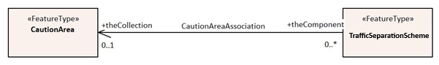
Figure 4-1 – Feature Association

Aggregation
An aggregation is a relationship between two or more feature types where the aggregation feature is made up of component features.
EXAMPLE A Bridge feature may be composed of multiple Span Fixed features.

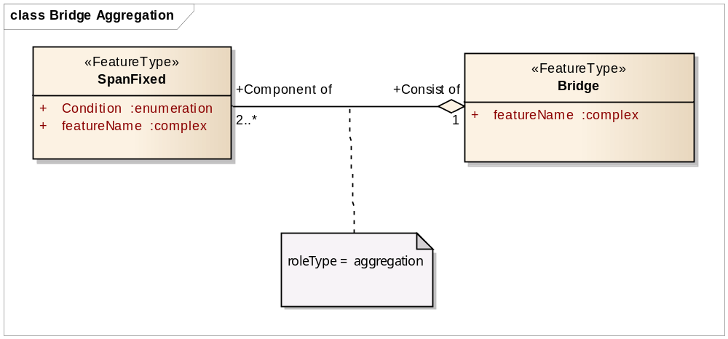
Figure 4-2 - Aggregation

Composition
A composition is a strong aggregation. In a composition, if a container feature is deleted then all of its container features are deleted as well.

EXAMPLE If a feature type that is considered a structure feature, such as a beacon is deleted, then all of its component feature types that make up the equipment composition, such as lights and fog signals must be deleted as they make up the Structure/Equipment Composition.

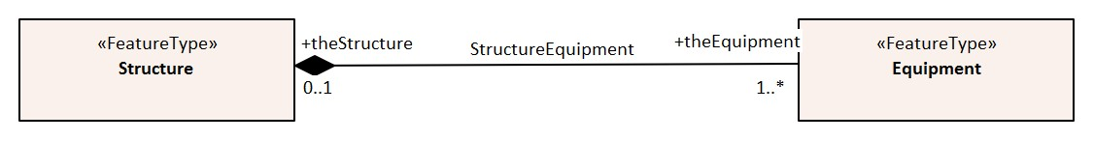
Figure 1-3 - Composition

Information Types
Details of information types can be found in Annex A – Data Classification and Encoding Guide, clause 2.3, 2.4.7 and Section 24.

Spatial Quality
Spatial quality attributes are carried in an information class called Spatial Quality. Details of spatial quality can be found in Annex A – Data Classification and Encoding Guide, clauses 2.4.7 and 24.5.

Information relationships
An information relationship links instances of an information type with instances of a feature type, spatial object, or information type. Just as with feature relationships, the relationship may take the form of an association, aggregation, or composition.

Information association
An information association is used to describe a relationship between a feature type, spatial object, or information type on one side and an information type on the other side.
EXAMPLE: A Nautical Information information type provides additional information to any geo feature using an information association called additional information.
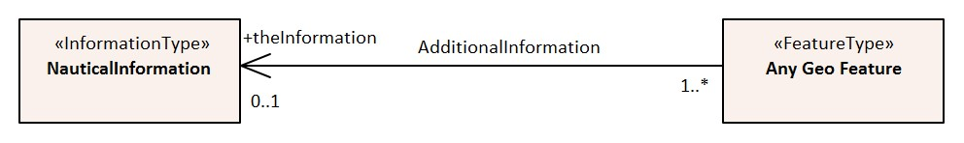
Figure 4-4 – Information association

Spatial associations
The information association “Spatial association” provides the binding between spatial objects and spatial quality. It is noted here because the S-100 Feature Catalogue model is incapable of describing this relationship.
Any spatial type other than surface may be associated with spatial quality (no use case for associating surfaces with spatial quality attributes has been identified). Vertical uncertainty is prohibited for curves as this dimension is not supported by curves.

Attributes
S-401 defines attributes as either simple or complex.

Simple Attributes
S-401 uses nine types of simple attributes; these types are listed in Annex A – Data Classification and Encoding Guide, clause 2.4.2. Descriptions of the simple attributes included in S-401 can be found in Annex A, Sections 27, 28 and 30.

Complex Attributes
Complex attributes are aggregations of other attributes that are either simple or complex. The aggregation is defined by means of attribute bindings. Examples of modelling complex attributes can be found in S-100 Part 2a, Appendix 2a-A. Descriptions of the complex attributes included in S-401 can be found in Annex A – Data Classification and Encoding Guide, Section 29.

Attribute suppression
The S-100 XML Feature Catalogue Schema allows for attributes to be suppressed in the end-user system Pick Report using the attribute attributeVisibility for the class S100_FC_AttributeBinding (see S-100 Part 5, Appendix 5-A, Tables 5-A-16 and 5-A-21) . These attributes are generally used to assist with optimum display of features in Inland ECDIS or ECS systems; or to perform other administrative roles. For S-401, these attributes are identified in the Feature Catalogue by population of attributeVisibility value “privateVisibility”.
The following is the list of S-401 attributes that will be suppressed in the Inland ECDIS or ECS Pick Report:
default clearance depth drawing index file locator
flare bearing in the water interoperability identifier
major light name usage sector arc extension
sector line length surrounding depth

Feature Object Identifier
Each real-world feature within an IENC must have a unique universal Feature Object Identifier. This identifier is formed by the binary concatenation of the contents of the subfields of the “Feature Object Identifier” [FOID] field. Information types must not have a FOID.
The FOID may be used to identify that the same feature has instances in separate datasets. For example, the same feature included in different maximum display scale datasets, or a feature being split by the IENC dataset limits within the same maximum display scale.
FOIDs must not be repeated in a dataset. Where a real-world feature has multiple parts within a single IENC dataset due to IENC dataset limit truncations, the feature will reference each spatial part of the feature within the dataset. This is accomplished in the ISO/EIC 8211 encoding by including a Spatial Association for each disjoint component. When a feature’s geometry is split each component must be represented by a separate spatial feature that the feature refers to.
Where a real-world feature is repeated in datasets of different maximum display scale, the FOID should be repeated for each instance of the feature across the maximum display scale range. Where this occurs, all instances of the geo feature must be identical, that is same feature class and attribute values.

Dataset

Introduction
A dataset is a grouping of features, attributes, geometry and metadata which comprises a specific coverage.

Dataset rules
In order to facilitate the efficient processing of IENC data the geographic coverage of a given optimum display scale may be split into multiple datasets (see clause 4.5.4).
The discovery metadata of a dataset must list all the Data Coverage features contained within that dataset and their assigned scale attributions.
An IENC update dataset must not change the limit of a Data Coverage feature for the base IENC dataset. Where the limit of a Data Coverage feature for a base IENC dataset is to be changed, this must be done by issuing a new edition of the dataset.
A dataset must not cross the 180° meridian.

Data Coverage rules
- All base datasets (new dataset, new edition and re-issue) must contain at least one Data Coverage feature.
- The data boundary of the IENC dataset is defined by the extent of the Data Coverage features and must be contained within the bounding box.
- Data Coverage features from different datasets covering the same geographical area must have non-overlapping display scale ranges (see clause 4.6). The scale ranges should, as much as possible, be continuous.
[Exception: At areas of agreed national data limits, where, if it is difficult to achieve a perfect join, an overlapping buffer zone of up to 5 metres may be used. For this situation, there must be no gaps in data between the adjoining datasets.]
Data Producers should develop consistent S-401 ENC schemes carefully and try to avoid complex situations, using a regional approach where possible.
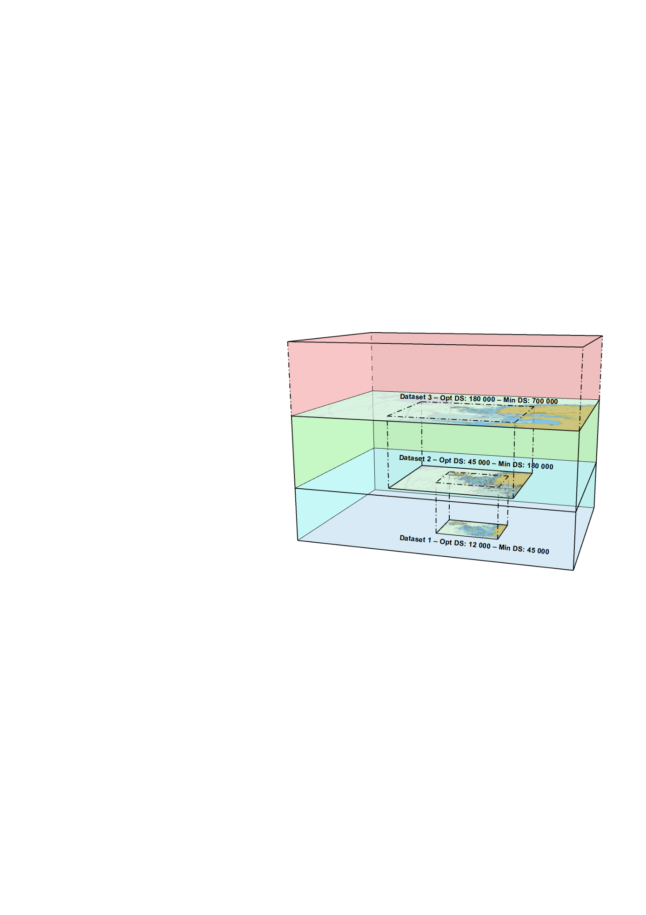
Figure 4-5 – Example of Datasets with single Data Coverage feature

- When a dataset has multiple Data Coverage features:
  - The minimum display scales must all be the same
  - The drawing indexes, where populated, must be the same
  - The optimum display scales may be different; and
  - The maximum display scales may be different.
- When a dataset has multiple Data Coverage features then the optimum display scale of the dataset must be equal to the largest optimum display scale of the Data Coverage features.

* The attribute drawing index is required where the datasets intended to form a seamless presentation in Inland ECDIS or ECS do not share a common minimum display scale. The attribute drawing index is also required if the dataset may need to form a seamless presentation with one or more S-57 datasets, in which case the value should correspond to the usage band of the adjoining or overlapping S-57 dataset(s). See S-401 Annex A – Data Classification and Encoding Guide, clauses 3.5 and 28.3.

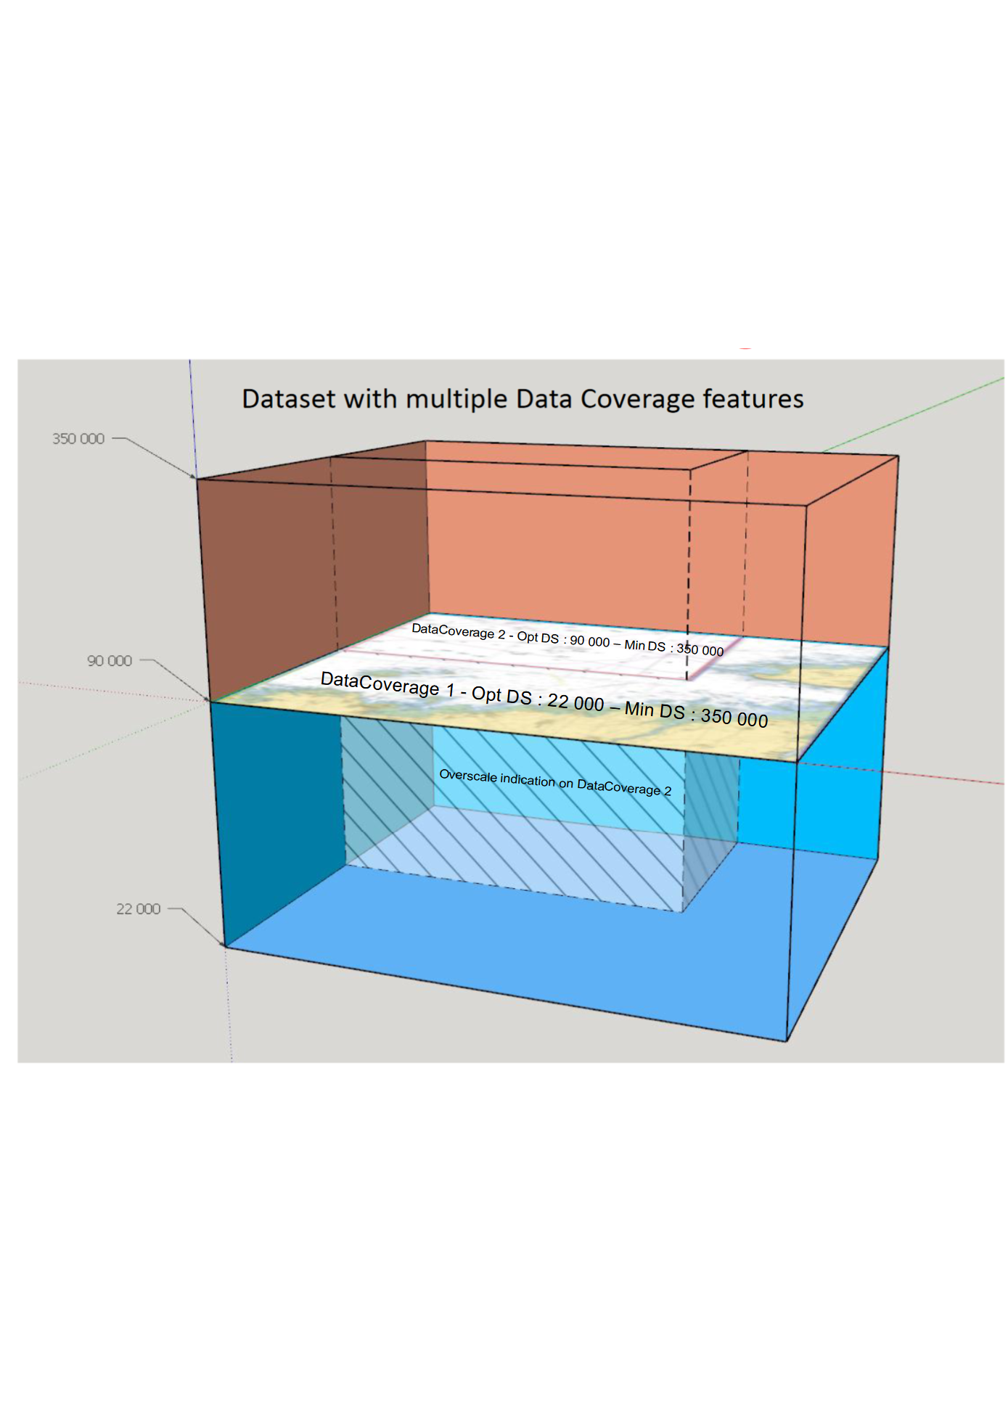
Figure 4-6 – Dataset with multiple Data Coverage features

Dataset size

Datasets must not exceed 10 MB.
Updates should not normally be larger than 1MB and must not be larger than 5 MB.

Display Scale Range
A scale range of a dataset is used to indicate a range of scales between which a producer considers the data is intended for use. (See clause 4.7 for how datasets are to be loaded and unloaded within a navigation system) The smallest scale is defined by the minimum display scale and the largest scale by the optimum display scale. The maximum display scale indicates the scale that the Data Producer considers that the “grossly overscaled” warning should be triggered. These scales must be set at one of the scales specified in clause 3 (spatial resolutions).
There must not be overlapping scale ranges (that is, overlaps between values of optimum display scale and minimum display scale) between datasets covering the same geographical area.
When the boatmaster’s selected viewing scale (BSVS) is smaller than the value indicated by minimum display scale, features within the Data Coverage feature are not displayed, except where the System Database does not contain a dataset covering the area at a smaller scale, in which case the dataset will be displayed at all smaller scales.
When the BSVS is larger than the value indicated by optimum display scale, the overscale indication, in the form of an overscale factor and pattern covering the area that is overscale, must be shown. When own vessel’s position is covered by a dataset with a larger optimum display scale than the BSVS is available, an indication is required and should be shown on the same screen as the chart display.
When the BSVS is larger than the value indicated by maximum display scale, the overscale indication, in the form of an overscale factor and, additionally, a pattern covering the area that is overscale, must be shown to indicate that the data is “grossly overscaled”.

Within IENC schemes it is preferable that the scale ranges for different datasets covering the same geographical area to be continuous (see clause 4.5.3). However, where the scale ranges are non-continuous, the IECDIS will display the larger scale dataset until the BSVS is equal to or at smaller scale than the optimum display scale of the next smaller scale dataset.

Dataset loading and display order
New algorithms for datasets loading and unloading, ande rendering (display) within a navigation system are prescribed in S-401 in order for the appropriate IENC to be viewed at the skipper’s selected viewing scale. This will simplify the process for the Inland ECDIS or ECS, giving clear and concise rules on how and when data is loaded and unloaded; and the order at which datasets are to be displayed. The concept of navigation purpose is restricted for use in presenting IENCs in a visual catalogue and must not be used for determining with dataset should be displayed.
Details of the dataset loading and data display algorithms are available in S-403 Annex C. Appendix C-5 – Dataset Loading Algorithm (Dataset Selection) and Dataset Display Order (Dataset Rendering).
Note 1: The algorithms only address loading and display related to visualization within the system graphics window. The application may need to load other datasets to satisfy requirements related to alerts processing, such as MSC.232(82) A11.2.
Note 2: Light sectors. It should be possible, on request, for the mariner to be capable of identifying the colour of the sectors affecting the ship, even if the lights involved are off the display.

Dataset loading algorithm (dataset selection)
See S-403 Annex C. Appendix C-5– Dataset Loading Algorithm (Dataset Selection) and Dataset Display Order (Dataset Rendering).

Dataset display order (dataset rendering)
See S-403 Annex C, Appendix C-5 – Dataset Loading Algorithm (Dataset Selection) and Dataset Display Order (Dataset Rendering) (in development).
Figures 4-7 to 4-10 below are intended to assist in understanding how the datasets should be displayed in the system graphics window:
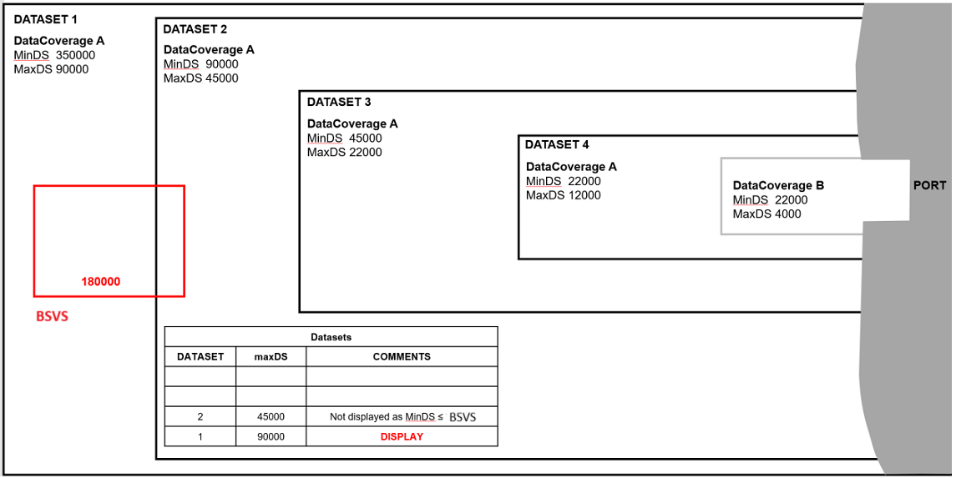
Figure 4-7 – Dataset loading – scenario 1
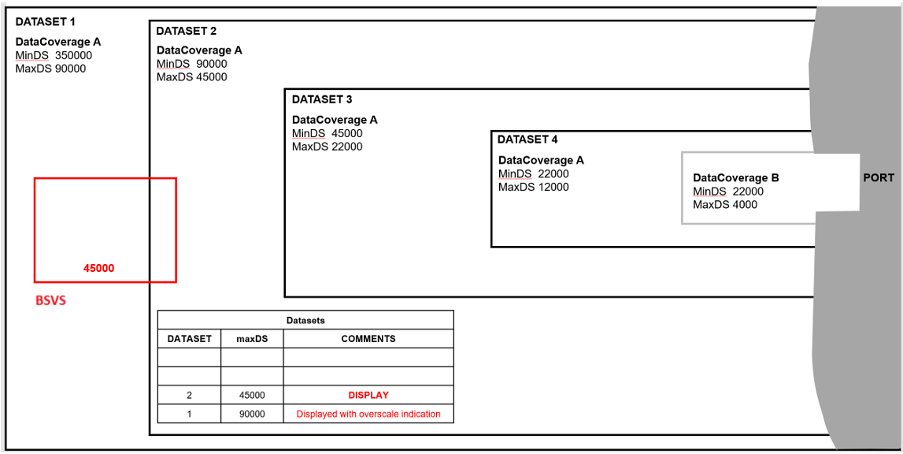
Figure 4-8 – Dataset loading – scenario 2

Figure 4-9 – Dataset loading – scenario 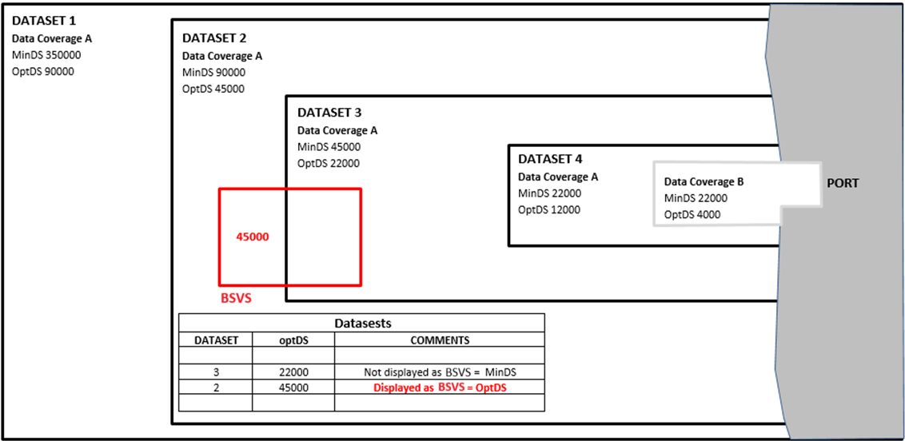3
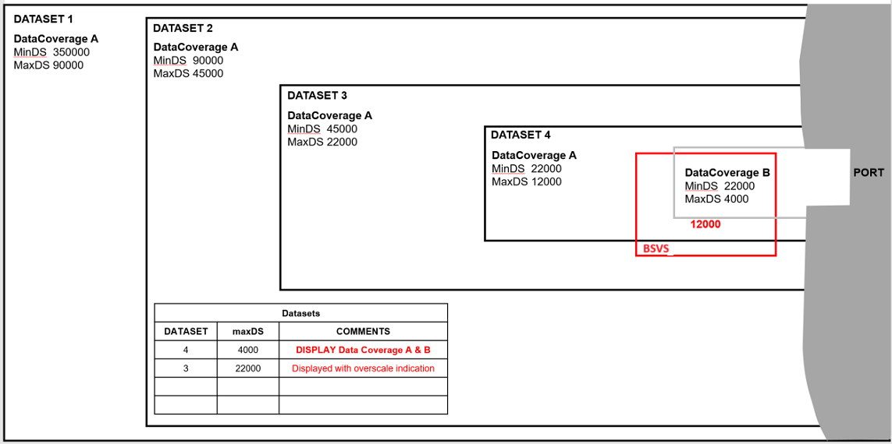
Figure 4-10 – Dataset loading – scenario 4

Geometry

S-100 Level 3a Geometry
The underlying geometry of an IENC is constrained to level 3a which supports 0, 1 and 2 dimensional features (points, curves and surfaces) as defined by S-100 Part 7 – Spatial Schema.
Level 3a is described by the following constraints:
- Each curve must reference a start and end point (they may be the same).
- Curves must not self intersect. See Figure 4-11.
- Areas are represented by a closed loop of curves beginning and ending at a common point.
- In the case of areas with holes, all internal boundaries must be completely contained within the external boundary and the internal boundaries must not intersect each other or the external boundary. Internal boundaries may touch other internal boundaries or the external boundary tangentially (That is at one point) as shown in Figure 4-12.
- The outer boundary of a surface must be in a clockwise direction (surface to the right of the curve) and the curve orientation positive. The inner boundary of a surface must be in a counter-clockwise direction (surface to the right of the curve) and the curve orientation negative. See Figure 4-13.

S-401 further constrains Level 3a with the following:
- Coincident linear geometry must be avoided when there is a dependency between features.
- The interpolation of GM_CurveSegment must be loxodromic.
- Linear geometry is defined by curves which are made of curve segments. Each curve segments contains the geographic coordinates as control points and defines an interpolation method between them. The distance between two consecutive control points must not exceed 0.3 mm at the maximum display scale.
- A feature may reference multiple geometries but must only reference geometries of a single geometric primitive (point, pointset, curve or surface).

The following exception applies to S-401:
- The use of coordinates is restricted to two dimensions, except in the case of soundings which use GM_Point or GM_Multipoint with three dimensional coordinates.

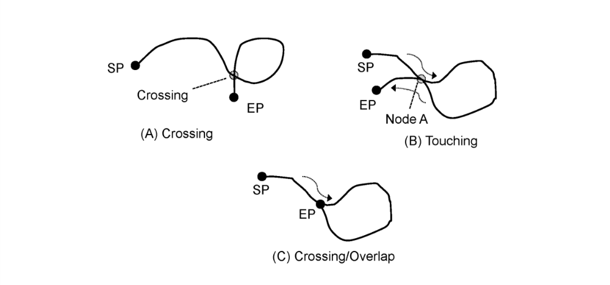
Figure 4-11 - Self Intersect Example

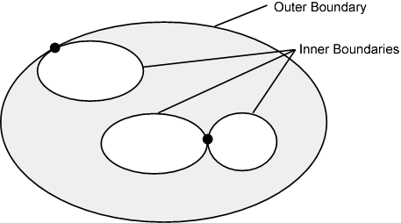

Figure 4-12 - Area Holes

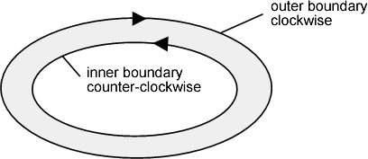
Figure 4-13 - Boundary Direction

Use of scale properties for feature to geometry relations
The attributes scaleMinimum and scaleMaximum of class S100_GF_SpatialAttributeType are not used. Therefore, the encoding must always encode the values ‘Not Applicable’.
Scale dependent depiction for the end user system is controlled by the thematic attribute scale minimum for the feature type only.

Masking
In certain circumstances, the symbolization of a curve may need to be suppressed. This is done using the Masked Spatial Type [MASK] field of the Feature Type record. The Mask Update Instruction [MUIN] must be set to {1} and Referenced Record name [RRNM] and Referenced Record identifier [RRID] fields must be populated with the values of the referenced spatial record. The Mask Indicator [MIND] must be set to either {1} or {2} (see Annex B – clause B.5.1.33)
Figure 4-14 is an example without masking and Figure 4-15 is an example of a masked edge between River and Depth Area features, where the River should be masked. In this example MIND is set to {2} – supress portrayal.

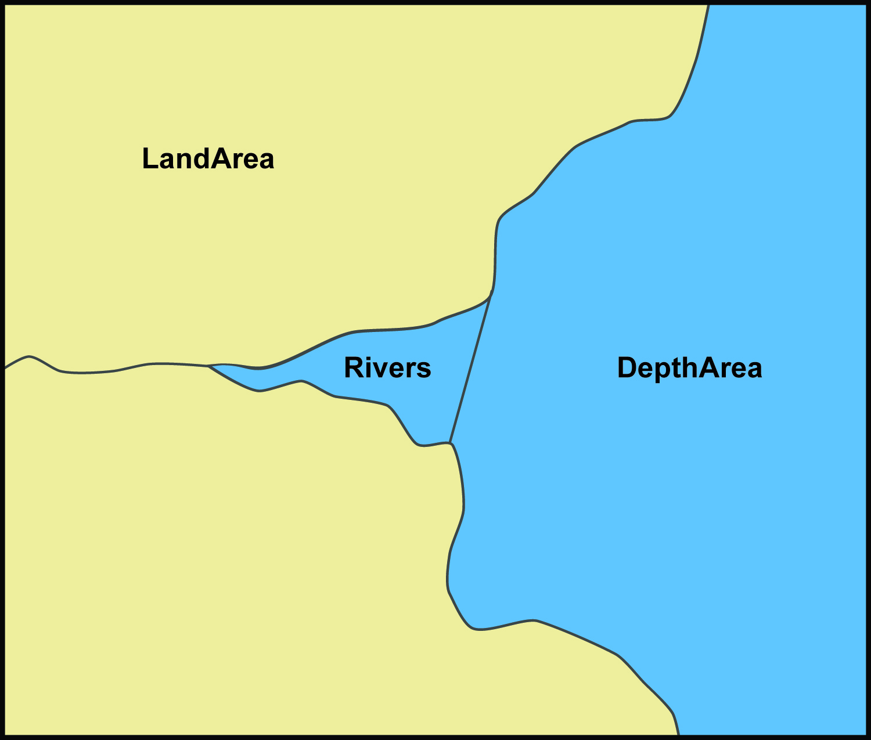
Figure 4-14 - Example without masking

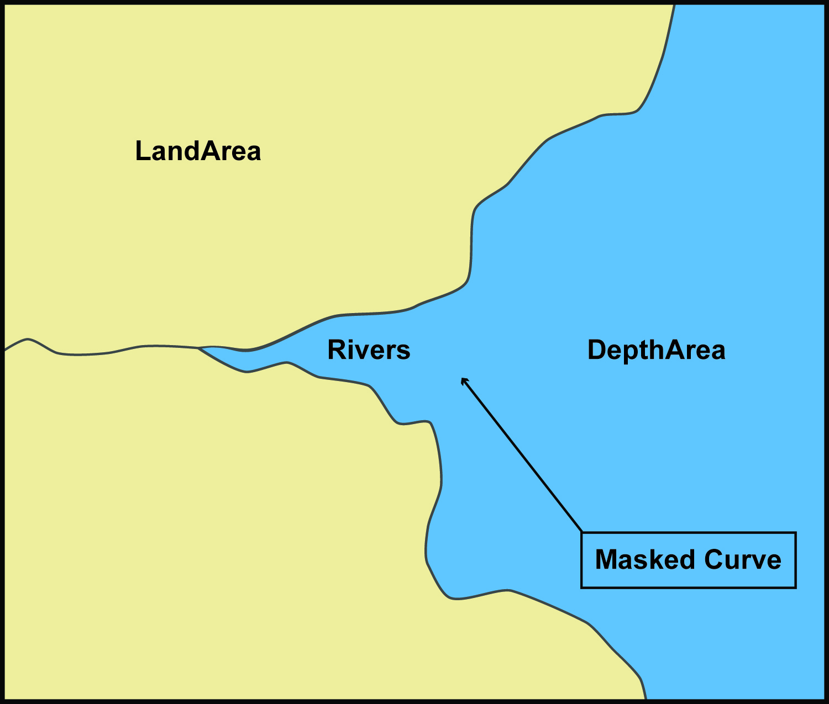
Figure 4-15 - Example with masking

Coordinate Reference Systems (CRS)

Introduction
An IENC dataset must define at least one compound CRS, which must be composed of one geodetic CRS and one vertical CRS. All compound CRSs within the same dataset must use the same geodetic CRS.
NOTE: The vertical CRS described in clause 5.3 below does not apply to depths, heights, elevations and vertical clearances where the information is encoded as an attribute rather than the vertical component (Z-coordinate) of the CRS. This vertical datum information is included in the IENC dataset using the meta features Sounding Datum and Vertical Datum of Data. See S-401 Annex A – Data Classification and Encoding Guide clauses 3.9 and 3.10.

Horizontal Coordinate Reference System
For IENC the horizontal CRS must be EPSG:4326 (WGS84). The full reference to EPSG: 4326 can be found at www.epsg-registry.org.

Horizontal coordinate reference system: EPSG:4326 (WGS84)
Projection: None
Temporal reference system: Gregorian calendar
Coordinate reference system registry: EPSG Geodetic Parameter Registry
Date type (according to ISO 19115): 002- publication
Responsible party: International Organisation of Oil and Gas Producers (IOGP) URL: https://www.iogp.org

Vertical CRS for Soundings
For IENC the vertical CRS must be in metres and is only relevant to soundings (S-401 features Sounding, see S-401 Annex A – Data Classification and Encoding Guide clause 3.9), where the depth information is stored in the Z-coordinate. Depths are represented by positive values, while negative values indicated intertidal (drying) soundings.
Although all coordinates in a dataset must refer to the same geodetic CRS, different Vertical Datums can be used for the depth component of a coordinate tuple. Therefore, the vertical CRS can be repeated. For each vertical CRS a unique identifier is defined. Those identifiers will be used to indicate which Vertical CRS is used.
The encoding of the Coordinate Reference System record fields can be found at Annex B, clauses B-5.1.9 to B-5.1.12; and is be demonstrated with the following examples. The example at Table 5-1 specifies a compound CRS. The first component of the first example is a 2D Geographic CRS (WGS84). The second component of the first example is a Vertical CRS for depth using the Vertical Datum: Mean High Water.

Table 5-1 – Compound CRS (WGS84 and mean high water)
Field | Subfield | Value | Description
CSID |  |  | Coordinate Reference System Record Identifier
 | RCNM | 15 | Record Name (15 = Coordinate Reference System Identifier)
 | RCID | 1 | Record Identification Number
 | NCRC | 2 | Number of CRS Components
CRSH |  |  | Coordinate Reference System Header
 | CRIX | 1 | CRS Index
 | CRST | 1 | CRS Type (1 = 2D Geographic)
 | CSTY | 1 | Coordinate System Type (1 = Ellipsoidal CS)
 | CRNM | WGS84 | CRS Name
 | CRSI | 4326 | CRS Identifier
 | CRSS | 2 | CRS Source (2 = EPSG)
 | SCRI |  | CRS Source Information (omitted)
CRSH |  |  | Coordinate Reference System Header
 | CRIX | 2 | CRS Index
 | CRST | 5 | CRS Type (5 = Vertical)
 | CSTY | 3 | Coordinate System Type (3 = Vertical)
 | CRNM | Depth - mean high water | CRS Name
 | CRSI |  | CRS Identifier (omitted)
 | CRSS | 255 | CRS Source (255 = Not Applicable)
 | SCRI |  | CRS Source Information (omitted)
CSAX |  |  | Coordinate System Axes
 | AXTY | 12 | Axis Type (12 = Gravity Related Depth)
 | AXUM | 4 | Axis Unit of Measure (4 = Metres)
VDAT |  |  | Vertical Datum
 | DTNM | mean high water | Datum Name
 | DTID | 16 | Datum Identifier (16 = Mean High Water)
 | DTSR | 2 | Datum Source (2 = Feature Catalogue)
 | SCRI |  | Datum Source Information (omitted)

The example at Table 5-2 is similar to the above except that its second component is encoded with the Vertical Datum: Mean Sea Level.
Table 5-2 – Compound CRS (WGS84 and Mean Sea Level)
Field | Subfield | Value | Description
CSID |  |  | Coordinate Reference System Record Identifier
 | RCNM | 15 | Record Name (15 = Coordinate Reference System Identifier)
 | RCID | 1 | Record Identification Number
 | NCRC | 2 | Number of CRS Components
CRSH |  |  | Coordinate Reference System Header
 | CRIX | 1 | CRS Index
 | CRST | 1 | CRS Type (1 = 2D Geographic)
 | CSTY | 1 | Coordinate System Type (1 = Ellipsoidal CS)
 | CRNM | WGS84 | CRS Name
 | CRSI | 4326 | CRS Identifier
 | CRSS | 2 | CRS Source (2 = EPSG)
 | SCRI |  | CRS Source Information (omitted)
CRSH |  |  | Coordinate Reference System Header
 | CRIX | 2 | CRS Index
 | CRST | 5 | CRS Type (5 = Vertical)
 | CSTY | 3 | Coordinate System Type (3 = Vertical)
 | CRNM | Depth - mean sea level | CRS Name
 | CRSI |  | CRS Identifier (omitted)
 | CRSS | 255 | CRS Source (255 = Not Applicabel)
 | SCRI |  | CRS Source Information (omitted)
CSAX |  |  | Coordinate System Axes
 | AXTY | 12 | Axis Type (12 = Gravity Related Depth)
 | AXUM | 4 | Axis Unit of Measure (4 = Metres)
VDAT |  |  | Vertical Datum
 | DTNM | mean sea level | Datum Name
 | DTID | 3 | Datum Identifier (3 = Mean Sea Level)
 | DTSR | 2 | Datum Source (2 = Feature Catalogue)
 | SCRI |  | Datum Source Information (omitted)

NOTE: For S-401, the vertical CRS encoded in the Coordinate Reference System record fields for soundings is not utilized by the Inland ECDIS or ECS in conveying the sounding datum information for an IENC to the boatmaster in Inland ECDIS or ECS. This information is provided instead using the S-401 meta feature Sounding Datum (see S-401 Annex A – Data Classification and Encoding Guide, clause 3.9).

Data Quality

Introduction
Data quality allows users and user systems to assess fitness for use of the provided data. Data quality measures and the associated evaluation are reported as metadata of a data product. This metadata improves interoperability with other data products and provides usage by user groups that the data product was not originally intended for. The secondary users can make assessments of the data product usefulness in their application based on the reported data quality measures.

For S-401 the following data quality elements have been included;
- Conformance to this Product Specification;
- Intended purpose of the data product;
- Completeness of the data product in terms of coverage;
- Logical Consistency;
- Depth Uncertainty and Accuracy;
- Positional Uncertainty and Accuracy;
- Thematic Accuracy;
- Temporal Quality;
- Aggregation measures;
- Validation checks or conformance checks including:
  - General tests for dataset integrity;
  - Specific tests for compliance against the S-401 data model.

In addition to conformance to the Data Quality elements detailed in clause 6.2 below, additional quantitative information may be provided to the user using relevant metadata features and attribution. The hierarchy of metadata provided in S-401 Annex A – Data Classification and Encoding Guide at Table 3-1 in clause 3.3 describes this further. For S-401 it is not relevant to provide a Data Quality Report to end users.

Completeness

Commission
Commission is applicable for S-401. Data Producers must verify that no excess items have been included in the dataset. This includes duplicate items, which must be removed.
S-401 Annex C – S-401 Validation Checks, includes data validation check(s) intended to identify excess and/or duplicate items.
If no excess or duplicate items are present the dataset PASSES this test.

Omission
Omission is applicable for S-401. Data Producers must verify that no items that should have been included in the dataset have been missed. This includes missing features specified as mandatory in S-101; and missing support files referenced by the dataset.
S-401 Annex C – S-401 Validation Checks, includes data validation check(s) intended to detect missing items.
If no items have been omitted the dataset PASSES this test.

Logical consistency

Conceptual consistency
Conceptual Consistency is applicable for S-401 and follows the guidelines from S-100 Part 1.
Data Producers must verify that the dataset conforms to the S-100 General Feature Model. S-401 Annex C – S-401 Validation Checks, provides validation checks which verify this conformance.
If no conceptual consistency checks classified as Critical in S-401 Annex C are reported the dataset PASSES this test.

Domain consistency
Domain consistency is applicable for S-401 and follows the guidelines from S-100 Part 5.
Data Producers must verify that the dataset conforms to the S-401 Feature Catalogue and rules described in the S-401 Annex A – Data Classification and Encoding Guide. S-401 Annex C – S-401 Validation Checks, provides validation checks which verify this conformance.
If no domain consistency checks classified as Critical in S-401 Annex C are reported the dataset PASSES this test.

Format consistency
Format Consistency is applicable for S-401 and follows the guidelines from S-100 Part 10a.
Data Producers must verify that the dataset conforms to S-401 Annex B – Data Product format (encoding). S-401 Annex C – S-401 Validation Checks, provides validation checks which verify this conformance.
If no format consistency checks classified as Critical in S-401 Annex C are reported the dataset PASSES this test.

Topological consistency
Topological consistency is applicable for S-401 and follows the guidelines from S-100 Part 7.
Data Producers must verify that the dataset conforms to the requirements for topology set out in Section 4 of this document. S-401 Annex C – S-401 Validation Checks, provides validation checks which verify this conformance.
If no topological consistency checks classified as Critical in S-401 Annex C are reported the dataset PASSES this test.

Positional uncertainty and accuracy

Absolute or external accuracy
Absolute or external accuracy is applicable for S-401 and follows the guidelines from S-100 Part 4c.
Data Producers must verify the absolute accuracy of S-401 datasets and ensure that they achieve an adequate accuracy. Additionally the relevant metadata features and attributes as described in S-401 Annex A – Data Classification and Encoding Guide, must be populated where applicable.

Vertical position accuracy
Vertical position accuracy is applicable for S-401 and follows the guidelines from S-100 Part 4c.
Data Producers must verify the vertical position accuracy of S-401 datasets and ensure that they achieve an adequate accuracy. The relevant metadata features and attributes as described in S-401 Annex A – Data Classification and Encoding Guide, should be populated to reflect the vertical position accuracy.

Horizontal position accuracy
Horizontal position accuracy is applicable for S-401 and follows the guidelines from S-100 Part 4c.
Data Producers must verify the horizontal position accuracy of S-401 datasets and ensure that they achieve an adequate accuracy. The relevant metadata features and attributes as described in S-401 Annex A – Data Classification and Encoding Guide, should be populated to reflect the horizontal position accuracy.

Relative or internal accuracy
Relative or internal accuracy is applicable for S-401 and follows the guidelines from S-100 Part 4c.
Data Producers must verify the relative or internal accuracy of S-401 datasets and ensure that they achieve an adequate accuracy.

Gridded data positional accuracy
Gridded data positional accuracy is not applicable for S-401.

Thematic accuracy

Thematic classification correctness
Thematic classification correctness is applicable for S-401 and follows the guidelines from S-100 Part 4c.
Data Producers must verify that features have been encoded correctly when included in the S-401 dataset. Encoded features must conform to the S-401 Feature Catalogue and the rules described in the S-401 Annex A – Data Classification and Encoding Guide. S-401 Annex C – S-401 Validation Checks, provides validation checks which verify this conformance.
If no thematic classification correctness checks classified as Critical in S-401 Annex C are reported the dataset PASSES this test.

Non-quantitative attribute accuracy
Non-quantitative attribute accuracy is applicable for S-401 and follows the guidelines from S-100 Part 4c.
Data Producers must verify that non-quantitative attributes have been populated correctly when included in the S-401 dataset. Non-quantitative attributes must conform to the S-401 Feature Catalogue and the rules described in the S-401 Annex A – Data Classification and Encoding Guide. S-401 Annex C – S-401 Validation Checks, provides validation checks which verify this conformance.
If no non-quantitative attribute checks classified as Critical in S-401 Annex C are reported the dataset PASSES this test.

Quantitative attribute accuracy
Quantitative attribute accuracy is applicable for S-401 and follows the guidelines from S-100 Part 4c.
Data Producers must verify that quantitative attributes have been populated correctly when included in the S-401 dataset. Quantitative attributes must conform to the S-401 Feature Catalogue and the rules described in the S-401 Annex A – Data Classification and Encoding Guide. Relevant metadata features and attributes must be used to indicate the accuracy where applicable. S-401 Annex C – S-401 Validation Checks, provides validation checks which verify this conformance.
If no quantitative attribute checks classified as Critical in S-401 Annex C are reported the dataset PASSES this test.

Temporal quality

Temporal consistency
Temporal consistency is applicable for S-401 and follows the guidelines from S-100 Part 4c.
Data Producers must verify that the dataset conforms to rules described in the S-401 Annex A – Data Classification and Encoding Guide. S-401 Annex C – S-401 Validation Checks, provides validation checks which verify this conformance.
If no temporal consistency checks classified as Critical in S-401 Annex C are reported the dataset PASSES this test.

Temporal validity
Temporal validity is applicable for S-401 and follows the guidelines from S-100 Part 4c.
Data Producers must verify that the dataset conforms to rules described in the S-401 Annex A – Data Classification and Encoding Guide. S-401 Annex C – S-401 Validation Checks, provides validation checks which verify this conformance.
If no temporal validity checks classified as Critical in S-401 Annex C are reported the dataset PASSES this test.

Temporal accuracy
Temporal accuracy is applicable for S-401 and follows the guidelines from S-100 Part 4c.
The Data Producer must verify the temporal accuracy of the S-401 dataset.

Aggregation
Aggregation is applicable for S-401. The aggregated data quality result provides a result if the dataset has passed conformance to the Product Specification.
The competent Data Producers must ensure that all applicable data quality aspects are checked and only if all of these checks are PASSED can the dataset be considered a valid S-401 dataset. This is indicated by the Data Producer signing the dataset.

Data Compliance and Usability
All S-401 datasets must be validated against the above data quality elements using conformance checks that are located in Annex C – IENC Validation Checks. As a minimum requirement, all datasets must conform to all checks that are categorized as “Critical” in Annex C.

S-401 datasets must conform to all mandatory elements of Annex A – Encoding Guide, where the word ‘must’ is used.

In addition to the above, dataset usability must be assessed against:
- Intended user requirements in regard to coverage, scale and specific content requirements as defined by the Producing Agency and key stakeholders;
- Conformance to established maintenance processes (see Section 8); and
- Overall compliance with the S-401 Product Specification, including context-specific evaluation of individual encoding instances for requirement of conformance to checks classified as “Error” and “Warning” in Annex C – IENC Validation Checks.

For dataset integrity requirements, see clause 11.6.

Data Capture and Classification

Introduction
The S-401 IENC Encoding Guide (DCEG) for Inland ENCs describes how data describing the real world should be captured using the types defined in the S-401 Feature Catalogue. This Guide is located in Annex A.

Maintenance

Introduction
This clause describes the requirements to adequately maintain datasets; use of newly acquired source data; maintenance requirements within the overall production process; and how Feature and Portrayal Catalogues are to be managed within an S-100 system.

Maintenance and Update Frequency
Datasets must be maintained as needed; and the overall production process must include mechanisms for IENC updating designed to meet the needs of the skipper regarding safety of navigation.

Data Source
Data Producers must use all available and applicable sources, as evaluated against a robust data assessment process to maintain and update IENC datasets as required.

Production Process
Data Producers should follow their established production processes for maintaining and updating datasets. Data is produced against S-401 Annex A – Data Classification and Encoding Guide, checked against S-401 Annex C – IENC Validation Checks and encapsulated in ISO/IEC 8211.
Only maintained datasets that conform to the mandatory requirements outlined in S-401 will be considered an IENC.

Feature and Portrayal Catalogue Management
For each new version of the S-401 Product Specification a new Feature and/or Portrayal catalogue will be released. The management of Feature and Portrayal Catalogues in end user systems is described in S-403 – Data Product Interoperability in S-100 Navigation Systems.

Portrayal

Introduction
S-401 portrayal is intended to contribute to the safe operation of an S-100 based navigation system by:
- Ensuring a base and supplementary levels of display for IENC data; standards of symbols, colours and their standardized assignment to features;
- Ensuring the display is clear and unambiguous,
- Establishing an accepted pattern for presentation that becomes familiar to skippers and so can be recognized instantly without confusion; and
- Utilizing the S-100 portrayal model to ensure interoperability.

To ensure that presentation remains intuitive, including where S-401 IENCs are used in conjunction with S-57 IENCs, the following principles must be followed when changes are made to the S-401 Portrayal Catalogue:
- S-401 may modify existing symbols, however key aspects such as shape and colour should be retained in order to ensure that the symbol remains identifiable;
- S-401 must maintain equivalence in terms of alerts and indications functionality in Inland ECDIS or ECS;
- The S-401 Portrayal Catalogue should be modified by extension. Symbols and Portrayal rules should be retained for items that have been superseded in the current version of S-401. This ensures that S-401 data produced to previous versions can be displayed using the latest Portrayal Catalogue.
S-401 portrayal is covered by the portrayal model as defined in S-100. This model reflects how the Portrayal Catalogue is defined for use in navigation systems. The Portrayal Catalogue defines symbology and the portrayal rules for each feature/attribute combination contained in the Feature Catalogue.
S-401 uses the portrayal process defined in S-100 Part 9A.
Items included in an S-401 Portrayal Catalogue must be registered in the IHO Geospatial Information (GI) Registry.

Portrayal Catalogue
Citation information for the Portrayal Catalogue is provided in Table 9-1 below.
Table 9-1 – S-401 Portrayal Catalogue
No. | ISO class or attribute | Type | Value
-- | CI_Citation | Class | --
1 | title | CharacterString | S-401 Portrayal Catalogue
2 | date | CI_Date (class) | --
2.1 | date | DateTime | 2025-12-31T00:00:00
2.2 | dateType | CI_DateTypeCode (ISO codelist) | publication
3 | edition | CharacterString | 1.3.0
4 | editionDate | DateTime | 2025-12-31T00:00:00
5 | citedResponsibleParty | CI_Responsibility (class) | --
5.1 | role | CI_RoleCode (ISO codelist) | publisher
5.2 | party | CI_Organisation (class) | --
5.2.1 | name | CharacterString | IEHG
6 | otherCitationDetails | CharacterString | (https://ienc.openecdis.org)
7 | onlineResource | CI_OnlineResource (class) | --
7.1 | linkage | CharacterString (URL) | http://registry.iho.int
7.2 | name | CharacterString | S-401 portrayal catalogue
7.3 | description | CharacterString | XML portrayal catalogue accompanied by related files for symbols, colour profiles, rules, etc.

The Portrayal Catalogue contains the mechanisms for the system to portray information found in S-401 IENCs. The S-401 Portrayal Catalogue contains the following types of mechanisms and structures:
- Set of portrayal rules
- Set of pixmaps, symbols, complex line styles, area filles, fonts and colour profiles
The portrayal catalogue model is defined in S-100 Part 9, clause 9-13.
The S-401 Portrayal Catalogue will be available in an XML document which conforms to the S-100 XML Portrayal Catalogue Schema. The structure for the Portrayal Catalogue is described in S-100 Part 9, clause 9-13.2.

Data Product format (encoding)

Introduction
This clause specifies the encoding for S-4101 datasets. See Annex B for a complete description of the data records, fields and subfields defined in the encoding.
Format Name: ISO/IEC 8211
Character Set: ISO 10646 Base Multilingual Plane
Specification: S-100 profile of ISO/IEC 8211 (part 10A)

Encoding of Latitude and Longitude
Coordinates are stored as integers. Latitude and longitude are converted to integers using a multiplication factor held in the Dataset Structure Information field under [CMFX] and [CMFY] (see Annex B – clause B1.6.3).
These coordinate multiplication factors must be set to {10000000} (10⁷) for all datasets.
EXAMPLE A longitude = 42.0000 is converted into X = longitude * CMFX = 42.0000 * 10000000 = 420000000.

Encoding of Depths as coordinates
Depths are converted from decimal metres to integers by means of the [CMFZ] (see Annex B – clause B1.6.3). This product limits the resolution to two decimal places and therefore the [CMFZ] must be set to {10}.
EXAMPLE: A depth = 4.2 is converted in Z = depth*CMFZ = 4.2*10 = 42

Numeric Attribute Encoding
Floating point and integer attribute values must not contain leading zeros. Floating point attribute values must not contain non-significant trailing zeros.

Text Attribute Values
Character strings must be encoded using the character set defined in ISO 10646-1, in Unicode Transformation Format-8 (UTF-8).

Unknown Attribute Values
In a base dataset and an update dataset, when an attribute code is present but the attribute value is missing, it means that the producer wishes to indicate that this attribute value is unknown.

In an update dataset, when an attribute code is present but the attribute value is missing it means:

• that the value of this attribute is to be replaced by an empty (null) value if it was present in the original dataset; or
• that an empty (null) value is to be inserted if the attribute was not present in the original dataset.

Data Product Delivery

Introduction
This clause specifies the encoding and delivery mechanisms for an S-401 IENC. Data which conforms to this product specification must be delivered by means of an exchange set.
The S-100 Exchange Set structure is described in S-100 Part 17, clause 17-4.1.

Exchange Set
S-401 datasets are grouped into Exchange Sets. Each Exchange Set consists of one or more IENC datasets with a single Exchange Catalogue XML file containing metadata, an associated XML Metadata file (S100_ResourcePurpose (ISOMetadata) – see S-100 Part 17, clause 17-4.5) may be included (see clause 11.5). It may also include one or more support files. The S-401 Exchange Set structure is the same as that described in S-100 Part 17-4.1.
Units of Delivery: Exchange Set
Transfer Size: Unlimited
Medium Name: Digital data delivery
Other Delivery Information:
Each Exchange Set has a single Exchange Catalogue which contains the discovery metadata for each dataset and references to any support files. See S-100 Part 17, clauses 17-4.4 and 17-4.5.

Dataset

Datasets
Four types of dataset files may be produced and contained within an exchange set:

- New dataset and new edition of a dataset (base dataset): Including new information which has not been previously distributed by updates. Each new edition of a dataset must have the same name as the dataset that it replaces. A new edition can also be IENC data that has previously been produced for this area and at the same maximum display scale. The encoding structure is located in Annex B – clause B-5

- Update: Changing some information in an existing dataset. Each Update dataset file must have the same name as the original base cell file, with an extension number greater than or equal to 001 (see EEE in clause 11.3.2 below). They must not extend the geographical area covered by the base cell file to which they apply (see clause 4.5.2). The encoding structure for an update is located in Annex D – clause B-6

- Re-issue of a dataset: including all the updates applied to the original dataset up to the date of the reissue. A re-issue is intended to avoid unnecessary lading of the Base cell and all applicable updates individually for new users of the dataset, therefor does not contain any new information additional to that previously issued by updates, and can be issued at any time. The encoding structure is located in Annex B – clause B-5

- Cancellation: The dataset is cancelled and is deleted from Inland ECDIS or ECS. The encoding structure for a cancellation file is located in Annex B – clause B-7

”File-less” management of published S-401 base datasets and their textual or pictorial ENC support files is not allowed for this Edition of S-401, with the exception of IENC support file deletions or metadata “supportedResource” updates. That is, producing a S-100 Exchange Set which only includes the mandatory “CATALOG.XML” file with the dataset and/or IENC Support File Discovery Metadata without including the appropriate dataset, dataset update or IENC support file in the S-100 Exchange Set is not allowed other than for the above exception.

Dataset file naming
401CCCCØØØØØØØØØØ.EEE

The file name forms a unique S-401 identifier where:
- 401 - the first 3 characters identify the dataset as an S-401 dataset (mandatory).
- CCCC - the fourth to seventh characters identify the producer code of the issuing agency (mandatory for S-401). Where the producer code is derived from a 2 or 3 character format (for instance when converting S-57 ENCs), the missing characters of the producer code must be populated with zeros (“00” or “0” respectively) for the sixth and seventh characters of the dataset file name, as required.
- ØØØØØØØØØØ –
- The eighth character indicates the navigational purpose (specificUsage).
- The letter “A” (in the position “specificUsage”) indicates, that the cell is displayed as overlay over other cells within a range of usages.
- The ninth to thirteenth characters (XXXXX) identify the waterway and the waterway distance.
- For waterways with a length of more than 999 km: for example D1923
- For waterways with a length of more than 99 km: for example RH123
- For waterways with a length of more than 9 km: for example DCC23
The use of the ninth to thirteenth characters is only a recommendation. In Brazilian waterways they identify the equivalent paper chart number.
The ninth to seventeenth characters are optional and may be used in any way by the producer to provide the unique file name. The following characters are allowed in the dataset name, A to Z, 0 to 9 and the special character _ (underscore).
- .EEE – new datasets and new editions use 000, updates start at 001 and increment until a limit of 999 (mandatory). Re-issues use the same number as the last Update applied to the dataset. Cancellations use the next sequential number from the previous Update applied to the dataset.

New Editions, Re-Issues, Updates and Cancellations
This section defines the sequencing of S-401 datasets for New Editions, Updates and Re-issues. In order to ensure that feature type updates are incorporated into an end user Inland ECDIS or ECS in the correct sequence without any omission, a number of parameters encoded in the data are used in the following way:
Edition number When a dataset is initially created (Base dataset), the Edition number 1 is assigned to it. The Edition number is increased by 1 at each New Edition.
Update number Update number 0 is assigned to a new dataset and a New Edition. The first Update dataset file associated with this new dataset must have Update number 1. The Update number must be increased by one for each consecutive Update, until a New Edition is released.
A Re-issue of a dataset must have the Update number of the last Update applied to the dataset, and use the same Edition number.

Issue date Date up to which the data producer has incorporated all applicable changes. The issue date must be greater than the previous issue date of the dataset.
In order to cancel a dataset, an Update dataset file is created for which the Edition number must be set to 0. This message is only used to cancel a Base dataset file. Where a dataset is cancelled and its name is reused at a later date, the issue date must be greater than the issue date of the cancelled dataset. When the dataset is cancelled it must be removed from the system.
An exchange set may contain Base dataset files and Update dataset files for the same datasets. Under these circumstances the Update dataset files must follow on in the correct sequential order from the last Update applied to the Base dataset file.

Support Files

IENC support files
IENC support files offer supplementary information that can be included in an IENC exchange set.
- Text files must contain only UTF-8 encoded text as defined by this standard (text consisting only of printable characters and without HTML, XML, or other markup).

- Picture files can be in JPEG or TIFF 6.0 specification (TIFF)

Table 11-1 – IENC support file extensions
File Types | Extensions | Comment
Text | TXT
 | XML | XML documents must only be included in accordance with guidance provided within the Encoding Guide (S-401 Annex A). This may include a schema for the validation of XML documents.
Picture | TIF | Baseline TIFF 6.0
 | JPG | JPEG2000

System support files
System support files used with the S-401 IENC Product Specification follow the general S-100 Framework principles without any specific S-401 IENC Product Specification restrictions. System support files include the Feature, Portrayal and Interoperability Catalogues; Language packs for Catalogues; and other system support files as required.

IENC support file naming
All IENC support files must have unique universal file identifiers. The file identifier of support information should not be used to describe the physical content of the file. The IENC support file metadata that accompanies the file will inform the user of the name and purpose of the file (That is new, replacement and deletion).
In this encoding the IENC support files are named according to the specifications given below:

401CCCCØØØØØØØØØØ.EEE
The main part forms an identifier where:
- 401 - the first 3 characters identify the IENC support file as applicable to an S-401 dataset (mandatory).
- CCCC - the fourth to seventh characters identify the producer code of the issuing agency (mandatory). Where the producer code is derived from a 2 or 3 character format (for instance when converting S-57 ENCs), the missing characters of the producer code must be populated with zeros (“00” or “0” respectively) for the sixth and seventh characters of the IENC support file name, as required.
- ØØØØØØØØØØ - the eighth to the maximum seventeenth characters are optional and can be used in any way by the producer to provide the unique IENC support file name. The following characters are allowed in the support file name: A to Z, 0 to 9 and the special character _ (underscore).

US: Format is AARRMMMXNN.EXT where:
AA = 2-character Producer Code
RR = 2-character river code
MMM = 3-digit river mile or river km, 000-999
X = tenth of river mile/km; preceding decimal point implied; use zero if river mile/km known only to the nearest mile.
NN = 01-99; unique identifier for text file at the particular river mile/km.
For example, if three TXTDSC files exist at the same river mile/km, 01, 02, and 03 would be used.
EXT = 3-character file extension for Hypertext Metafile (HTM), ASCII text (TXT), or Standardized External XML file with communication information.
EUR: The ISRS Location Code or a UUID can be used for the file name of the external XML files, for example DEXXX039000000005023.XML.

- .EEE – IENC support file extension. (TXT, XML or TIF or JPG).

Support file management
When a support file is created or a subsequent version is issued it must carry its own issue date and it may be supported with a digital signature which authenticates it against the Producer’s public key included in the exchange set metadata.

The “revisionStatus” field of the support file discovery metadata defines if the support file is new, replacement or deletion.

The “purpose” field of catalogue discovery metadata defines if the Catalogue is a new edition or a cancellation.
Support files carrying the “deletion” or “cancellation” flag must be removed or archived. Upon receiving an IENC support file with the “SupportFileDiscoveryMetaData” field “revisionStatus” populated as “deletion” is received, the Inland ECDIS or ECS software must check to see whether any features reference the IENC support file, prior deleting or archiving the file.

Support files, with the exception of Catalogue files, must be stored in a separate folder within the Exchange Set named SUPPORT_FILES. The Catalogue files must be stored within the Exchange Set in a folder named “CATALOGUES”. Refer to S-100 Part 17, clause 17-4.2 Figure 17-3 – An S-100 Exchange Set folder structure.
Reuse of a IENC support file name after a deletion is possible only if the IENC support file edition number is higher than the previous edition number before the deletion.
Only the latest edition of a support file can be used. As soon as a new edition is created and installed, the older version is retired and can no longer be used by any feature.
If an IENC support file is associated with multiple features in one or several datasets, a new edition of the file will immediately be used by all associated features.
If a New Edition of an IENC support file contains changes not applicable to all previous associated features, a completely new IENC support file must be created instead. This is to maintain the IENC support file information for the associated features not effected by the changes. The associations to the original file must then be removed for the relevant features and new associations created for the new IENC support file and applied by IENC update. Features where changes were not applicable will continue to use the original IENC support file.
In all cases, the ENC update(s) and the associated new or updated IENC support file(s) must be included in the same Exchange Set. If the original IENC support file’s supportFileDiscoveryMetadata “supportedResource” was originally populated to reference one of more IENCs, then it can be updated in the CATALOG.XML without adding the original IENC support file in the Exchange set.

The following scenario demonstrates the rules related to versioning and issuing of new IENC support files:
Three Caution areas are encoded within three different IENCs. All of them references the same IENC support file A:

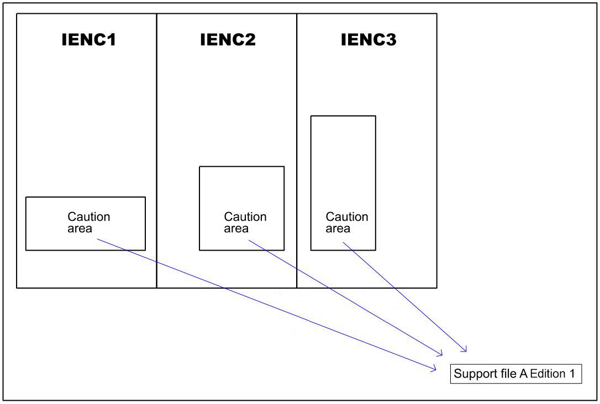
Figure 11-1 – Reference to new support file
Figure 11-2: Changes occur making it necessary to issue a New Edition of IENC support file A. Edition 1 is no longer valid, and all 3 caution areas refer to the New Edition of IENC support file A (Edition 1 of the file is deleted from the system or not used if no longer referenced by any IENC features):

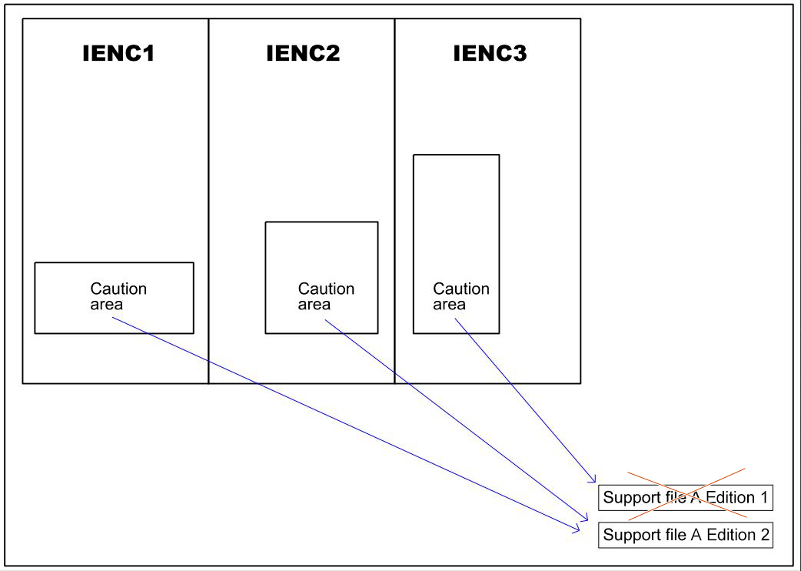
Figure 11-2 – Reference to a New Edition of an IENC support file
Figure 11-3: Changes occur that are only applicable to the Caution areas in IENC 1 and IENC 2. Consequently, these IENCs can no longer refer to IENC support file A Edition 2:
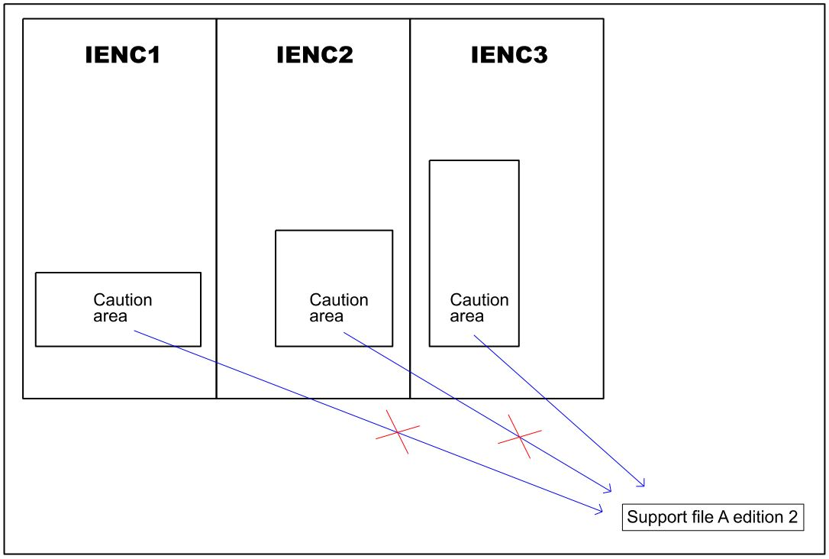
Figure 11-3 – Changes to IENC support file affecting limited referenced features
Figure 11-4: A new IENC support file B must be created for IENC 1 and IENC 2 to use as reference:
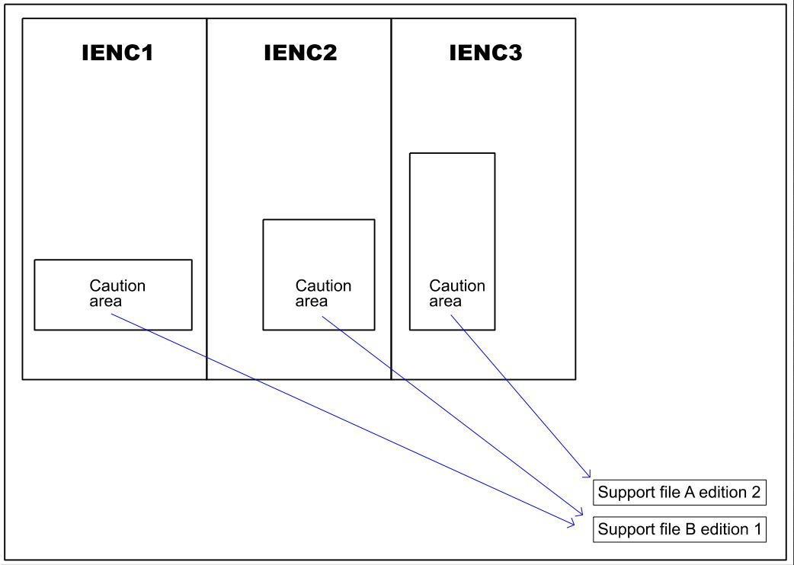
Figure 11-4 – A new IENC support file affecting limited referenced features
NOTE: In Figure 11-4, if the IENC support file A Edition 2 Support File Discovery Metadata attribute “supportedResource” has been populated with all the previous IENC references, then the IENC support file A Edition 2 Support File Discovery Metadata should also be included and updated in the update Exchange Set CATALOG.XML with the “supportedResource” updated accordingly – now referencing only “IENC 3”.
To simplify this process consideration may be given to not populating the IENC Support File Discovery Metadata attribute “supportedResource” where the IENC support file is referenced in more than one IENC product (see S-100 Part 17, clause 17-4.3.1 – Supported resources / multiple references guide).

Associated XML Metadata file
An associated XML Metadata file is expected to carry information specific to producing authorities’ internal production procedures, and is not intended for use within the end user systems.
If used, all associated XML Metadata files must have unique names. The name of the associated XML Metadata file should not be used to describe the physical content of the file.
The associated XML Metadata file must be named according to the specification given below:
MD_<data file base name>.XML

S-401 Exchange Catalogue
The S-401 exchange catalogue acts as the table of contents for the S-100 exchange set. The catalogue file of the exchange set must be named CATALOG.XML. No other file in the exchange set may be named CATALOG.XML. The contents of the S-401 exchange catalogue are described in Clause 12.

Data integrity and encryption
See S-100 Parts 15 and 17.

Metadata

Introduction
For information exchange, there are several categories of metadata required: metadata about the overall exchange catalogue, metadata about each of the datasets contained in the catalogue, and metadata about the support files that make up the package.
S-100 Part 17, Figures 17-1, 17-6 and 17-7 outline the overall concept of an S-100 Exchange Set for the interchange of geospatial data and its relevant metadata. Figure 17-1 depicts the realization of the ISO 19115-1 and 19115-3 classes which form the foundation of the Exchange Set. The overall structure of S-401 metadata for Exchange Sets is the same as S-100 metadata., Figure 17-6 depicts the structure of the Exchange Set Catalogue and the structure of the Exchange Set as included in S-100 part 17, Figure 17-1 is also described in clause 11.2 above. More detailed information about the various classes is shown in Figure 17-7 and a textual description in the tables at clauses 12.1.1 to 12.1.4.
The discovery metadata classes have numerous attributes which expose important information about the IENCs, IENC support files and system support files to be examined without the need to process the data, for example, decrypt, decompress, load etc.
System support files, such as Feature and Portrayal Catalogues or codelist dictionary files, can be included in the Exchange Set in support of the end-user system. The attribute “resourcePurpose” of the IENC Support File Discovery Metadata provides a mechanism to “read” and apply these system support files more easily.
The following clauses define the mandatory and optional metadata needed for S-401. In some cases, the metadata may be repeated in a national language. If this is the case it is noted in the Remarks column.
In the following clauses, wherever S-401 makes an optional S-100 metadata attribute mandatory (that is, restricts multiplicity from 0.. to 1..), the restricted multiplicity is shown in place of the multiplicity given in S-100 Part 17, and a comment noting the restricted multiplicity has been included in the Remarks column.

S100_ExchangeCatalogue
The Exchange Catalogue inherits the Dataset Discovery Metadata, Support File Discovery Metadata and Catalogue Discovery Metadata from S-100 with additional S-401-specific restrictions.
Name | Description | Mult | Type | Remarks
S100_ExchangeCatalogue | An Exchange Catalogue contains the discovery metadata about the exchange datasets and support files | - |  | -
identifier | Uniquely identifies this Exchange Catalogue | 1 | S100_ExchangeCatalogueIdentifier | 0..1 multiplicity in S-100 restricted to 1 in S-401
contact | Details about the issuer of this Exchange Catalogue | 1 | S100_CataloguePointOfContact | 0..1 multiplicity in S-100 restricted to 1 in S-401
productSpecification | Details about the Product Specifications used for the datasets contained in the Exchange Catalogue | 1,.* | S100_ProductSpecification | The Exchange Catalogue may contain datasets from Product Specifications other than S-401  0..* multiplicity in S-100 restricted to 1..* in S-401
defaultLocale | Default language and character set used for all metadata records in this Exchange Catalogue | 1 | PT_Locale | All datasets conforming to S-101 Product Specification must use English language as default locale  0..1 multiplicity in S-100 restricted to 1 in S-401
otherLocale | Other languages and character sets used for the localized metadata records in this Exchange Catalogue | 0..* | PT_Locale | Required if any localized entries are present in the Exchange Catalogue
exchangeCatalogueDescription | Description of what the Exchange Catalogue contains | 0..1 | CharacterString
exchangeCatalogueComment | Any additional Information | 0..1 | CharacterString
certificates | Signed public key certificates referred to by digital signatures in the Exchange Set | 0..* | S100_SE_CertificateContainerType | Content defined in S-100 Part 15. All certificates used, except the SA root certificate (installed separately by the implementing system) shall be included
dataServerIdentifier | Identifies the data server for the permit | 0..1 | CharacterString
datasetDiscoveryMetadata | Exchange Catalogues may include or reference discovery metadata for the datasets in the Exchange Set | 0..* | Aggregation S100_DatasetDiscoveryMetadata
catalogueDiscoveryMetadata | Metadata for Catalogue | 0..* | Aggregation S100_CatalogueDiscoveryMetadata | Metadata for the Feature, Portrayal, and Interoperability Catalogues, if any
supportFileDiscoveryMetadata | Exchange Catalogues may include or reference discovery metadata for the support files in the Exchange Set | 0..* | Aggregation S100_SupportFileDiscoveryMetadata

S100_ExchangeCatalogueIdentifier
Role Name | Name | Description | Mult | Type | Remarks
Class | S100_ExchangeCatalogueIdentifier | An Exchange Catalogue contains the discovery metadata about the exchange datasets and support files | - | - | The concatenation of identifier and dateTime form the unique name
Attribute | identifier | Uniquely identifies this Exchange Catalogue | 1 | CharacterString | <S100XC:identifier>US_401_20200101_120101_01</S100XC:identifier>
Attribute | dateTime | Creation date and time of the Exchange Catalogue, including time zone | 1 | DateTime | Format: yyyy-mm-ddThh:mm:ssZ

S100_CataloguePointOfContact
Role Name | Name | Description | Mult |  | Type | Remarks
Class | S100_CataloguePointOfContact | Contact details of the issuer of this Exchange Catalogue | - | - |  | -
Attribute | organization | The organization distributing this Exchange Catalogue | 1 | CharacterString |  | This could be an individual producer, value added reseller, etc
Attribute | phone | The phone number of the organization | 0..1 | CI_Telephone
Attribute | address | The address of the organization | 0..1 | CI_Address

S100_DatasetDiscoveryMetadata
Name | Description | Mult | Type | Remarks
S100_DatasetDiscoveryMetadata | Metadata about the individual datasets in the Exchange Catalogue | - | - | -
fileName | Dataset file name | 1 | URI | See S-100 Part 1, clause 1-4.6
description | Short description giving the area or location covered by the dataset | 0..1 | CharacterString | For example, a harbour or port name, between two named locations etc  See also Note 1
datasetID | Dataset ID expressed as a Maritime Resource Name (MRN) | 0..1 | URN | The URN must be an MRN
compressionFlag | Indicates if the resource is compressed | 1 | Boolean | True indicates a compressed dataset resource  False indicates an uncompressed dataset resource
dataProtection | Indicates if the data is encrypted | 1 | Boolean | True indicates an encrypted dataset resource  False indicates an unencrypted dataset resource
protectionScheme | Specification of method used for data protection | 0..1 | S100_ProtectionScheme
digitalSignatureReference | Specifies the algorithm used to compute digitalSignatureValue | 1 | S100_SE_DigitalSignatureReference (see S-100 Part 15)
digitalSignatureValue | Value derived from the digital signature | 1..* | S100_SE_DigitalSignature (see S-100 Part 15) | The value resulting from application of digitalSignatureReference.  Implemented as the digital signature format specified in S-100 Part 15
copyright | Indicates if the dataset is copyrighted | 1 | Boolean | True indicates the resource is copyrighted  False indicates the resource is not copyrighted
classification | Indicates the security classification of the dataset | 1 | Class  MD_SecurityConstraints>MD_ClassificationCode (codelist) | 1. unclassified  2. restricted  3. confidential  4. secret  5. top secret  6. sensitive but unclassified  7. for official use only  8. protected  9. limited distribution  0..1 multiplicity in S-100 restricted to 1 in S-401
purpose | The purpose for which the dataset has been issued | 1 | S100_Purpose | 0..1 multiplicity in S-100 restricted to 1 in S-401
notForNavigation | Indicates the dataset is not intended to be used for navigation | 1 | Boolean | True indicates the dataset is not intended to be used for navigation  False indicates the dataset is intended to be used for navigation
specificUsage | The use for which the dataset is intended | 0..1 | MD_USAGE>specificUsage (character string)
editionNumber | The Edition number of the dataset | 1 | Integer | When a dataset is initially created, the Edition number 1 is assigned to it. The Edition number is increased by 1 at each New Edition. Edition number remains the same for update and re-issue  0..1 multiplicity in S-100 restricted to 1 in S-401
updateNumber | Update number assigned to the dataset and increased by one for each subsequent update | 1 | Integer | Update number 0 is assigned to a new dataset  0..1 multiplicity in S-100 restricted to 1 in S-401
updateApplicationDate | This date is only used for the base cell files (that is new data set, re-issue and new edition), not update cell files. All updates dated on or before this date must have been applied by the producer | 0..1 | Date
referenceID | Reference back to the datasetID | 0..1 | URN | Update metadata refers to the datasetID of the dataset metadata. This is used if and only if the dataset is an update  The URN must be an MRN
issueDate | Date on which the data was made available by the Data Producer | 1 | Date
issueTime | Time of day at which the data was made available by the Data Producer | 0..1 | Time | The S-100 datatype Time
boundingBox | The extent of the dataset limits | 1 | EX_GeographicBoundingBox | 0..1 multiplicity in S-100 restricted to 1 in S-401
temporalExtent | Specification of the temporal extent of the dataset | 0..1 | S100_TemporalExtent | The temporal extent is encoded as the date/time of the earliest and latest data records (in coverage datasets) or date/time ranges (in vector datasets)  If there is more than one feature in a dataset, the earliest and latest time values of records in all features are used, which means the earliest and latest values may be from different features  If date/time information for a feature is not encoded in the dataset, it is treated for the purposes of this attribute as extending indefinitely in the appropriate direction on the time axis, limited by the issue date/time or the cancellation or supersession of the dataset  This attribute is encoded if and only if at least one of the start and end of the temporal extent is known
productSpecification | The Product Specification used to create this dataset | 1 | S100_ProductSpecification
producingAgency | Agency responsible for producing the data | 1 | CI_Responsibility>CI_Organisation | See S-100 Part 17, Table 17-3
producerCode | The official IHO S-100 Producer Code from the IHO GI Registry, Producer Code Register | 1 | CharacterString | 0..1 multiplicity in S-100 restricted to 1 in S-401
encodingFormat | The encoding format of the dataset | 1 | S100_EncodingFormat | For S-401 datasets must be ISO/IEC 8211
dataCoverage | Provides information about data coverages within the dataset | 1..* | S100_DataCoverage | 0..* multiplicity in S-100 restricted to 1..* in S-401
comment | Any additional information | 0..1 | CharacterString
defaultLocale | Default language and character set used in the dataset | 0..1 | PT_Locale | In absence of defaultLocale the language is English, UTF-8
otherLocale | Other languages and character sets used in the dataset | 0..* | PT_Locale
metadataPointOfContact | Point of contact for metadata | 0..1 | CI_Responsibility>CI_Individual or  CI_Responsibility>CI_Organisation | Only if metadataPointOfContact is different to producingAgency
metadataDateStamp | Date stamp for metadata | 0..1 | Date | Metadata creation date, which may or may not be the dataset creation date
replacedData | Indicates if a cancelled dataset is replaced by another data file(s) | 0..1 | Boolean | See Note 2
dataReplacement | Dataset name | 0..* | CharacterString | A dataset may be replaced by 1 or more datasets  See Note 2
navigationPurpose | Classification of intended navigation purpose (for Catalogue indexing purposes) | 1 | S100_NavigationPurpose | 0..3 multiplicity in S-100 restricted to 1 in S-401
resourceMaintenance | Information about the frequency of resource updates, and the scope of those updates | 0..1 | MD_MaintenanceInformation | S-100 restricts the multiplicity to 0..1 and adds specific restrictions on the ISO 19115 structure and content. See clause MD_MaintenanceInformation later in this Part  Format: PnYnMnDTnHnMnS (XML built-in type for ISO 8601 duration). See S-100 Part 17, clause 17-4.9

NOTE 2: replacedData and dataReplacement: The attribute replacedData is mandatory if the attribute purpose (see clause 12.1.2.3) is set to value 5 (cancellation). The attribute dataReplacement is mandatory if replacedData = True.

S100_NavigationPurpose
Item | Name | Description | Code | Remarks
Enumeration | S100_NavigationPurpose | The purpose of the dataset | -
Value | port | For port and near shore operations | 1 | -
Value | transit | For coast and planning purposes | 2 | -
Value | overview | For ocean crossing and planning purposes | 3 | -

S100_DataCoverage
Name | Multiplicity | Value | Type | Remarks
S100_DataCoverage | - | - | - | -
boundingPolygon | 1 |  | EX_BoundingPolygon
temporalExtent | 0..1 |  | S100_TemporalExtent | The remarks for temporalExtent in the dataset discovery block (S100_DatasetDiscoveryMetadata) apply, except that their scope is the individual coverage and not the dataset as a whole
optimumDisplayScale | 1 |  | Integer | Must be one of the following values:  200  500  1000  2000  3000  4000  8000  12000  22000  45000  90000  180000  350000  700000  1500000  3500000  10000000  0..1 multiplicity in S-100 restricted to 1 in S-401
maximumDisplayScale | 1 |  | Integer | Any value  0..1 multiplicity in S-100 restricted to 1 in S-401
minimumDisplayScale | 1 |  | Integer | Must be one of the following values:  200  500  2000  3000  4000  8000  12000  22000  45000  90000  180000  350000  700000  1500000  3500000  10000000  NULL  0..1 multiplicity in S-100 restricted to 1 in S-401

S100_Purpose
Item | Name | Description | Code | Remarks
Enumeration | S100_Purpose | The purpose of the dataset | -
Value | newDataset | Brand new dataset | 1 | No data has previously been produced for this area
Value | newEdition | New edition of the dataset or Catalogue | 2 | Includes new information which has not been previously distributed by updates
Value | update | Dataset update | 3 | Changing some information in an existing dataset
Value | reissue | Dataset that has been re-issued | 4 | Includes all the updates applied to the original dataset up to the date of the re-issue. A re-issue does not contain any new information additional to that previously issued by updates
Value | cancellation | Dataset or Catalogue that has been cancelled | 5 | Indicates the dataset or Catalogue should no longer be used and can be deleted

S100_TemporalExtent
Role Name | Name | Description | Mult | Type | Remarks
Class | S100_TemporalExtent | Temporal extent | -- |  | At least one of the timeInstantBegin and timeInstantEnd attributes must be populated; if both are known, both must be populated. The absence of either begin or end indicates indefinite validity in the corresponding direction, limited by the issue date/time or the cancellation or supersession of the dataset
Attribute | timeInstantBegin | The instant at which the temporal extent begins | 0..1 | DateTime
Attribute | timeInstantEnd | The instant at which the temporal extent ends | 0..1 | DateTime

S100_EncodingFormat
Item | Name | Description | Code | Remarks
Enumeration | S100_EncodingFormat | The encoding format | - | Values listed in S-100 Part 17 but not mentioned in this table are not allowed
Value | ISO/IEC 8211 | The ISO 8211 data format as defined in S-100 Part 10a | 1

S100_ProductSpecification
Role Name | Name | Description | Mult | Type | Remarks
Class | S100_ProductSpecification | The Product Specification contains the information needed to build the specified product | - | - | -
Attribute | name | The name of the product specification used to create the datasets | 1 | CharacterString | S401 Inland Electronic Navigational Charts  0..1 multiplicity in S-100 restricted to 1 in S-401
Attribute | version | The version number of the product specification | 1 | CharacterString | 1.3.0  0..1 multiplicity in S-100 restricted to 1 in S-401
Attribute | date | The version date of the product specification | 1 | Date | 0..1 multiplicity in S-100 restricted to 1 in S-401
Attribute | productIdentifier | Machine readable unique identifier of a product type | 1 | CharacterString  (Restricted to Product ID values from the IHO Product Specification Register, in the IHO Geospatial Information (GI) Registry) | “S-401” (without quotes)
Attribute | number | The number (registry index) used to lookup the product in the Product Specification Register | 1 | Integer | From the Product Specification Register in the IHO Geospatial Information Registry
Attribute | compliancyCategory | The level of compliance of the Product Specification to S-100 | 1 | S100_CompliancyCategory | 0..1 multiplicity in S-100 restricted to 1 in S-401. Needed for S-98 interoperability

S100_CompliancyCategory
Item | Name | Description | Code | Remarks
Enumeration | S100_CompliancyCategory |  | - | All S-401 products fully conforming to this Product Specification would be category3 if not otherwise stated by IEHG
Value | category3 | IHO S-100 compliant with standard encoding | 3
Value | category4 | IHO S-100 and IMO harmonized display compliant | 4

S100_ProtectionScheme
Item | Name | Description | Code | Remarks
Enumeration | S100_ProtectionScheme | Data protection schemes | - | -
Value | S100p15 | IHO S-100 Part 15 | 1 | See S-100 Part 15

S100_SupportFileDiscoveryMetadata
Name | Description | Mult | Type | Remarks
S100_SupportFileDiscoveryMetadata | Metadata about the individual support files in the Exchange Catalogue | - | - | -
fileName | Name of the support file | 1 | URI | See S-100 Part 1, clause 1-4.6
revisionStatus | The purpose for which the support file has been issued | 1 | S100_SupportFileRevisionStatus | For example new, replacement, etc
editionNumber | The Edition number of the support file | 1 | Integer | When a data set is initially created, the Edition number 1 is assigned to it. The Edition number is increased by 1 at each new Edition. Edition number remains the same for a re-issue
issueDate | Date on which the data was made available by the Data Producer | 0..1 | Date
supportFileSpecification | The specification used to create this file | 1 | S100_SupportFileSpecification | 0..1 multiplicity in S-100 restricted to 1 in S-401.
dataType | The format of the support file | 1 | S100_SupportFileFormat | Constrained to TXT, TIF and JPG – see clause 11.4.1
comment | Optional comment | 0..1 | CharacterString | Any additional Information
compressionFlag | Indicates if the resource is compressed | 1 | Boolean | True indicates a compressed resource  False indicates an uncompressed resource
digitalSignatureReference | Specifies the algorithm used to compute digitalSignatureValue | 1 | S100_SE_DigitalSignatureReference (see Part 15)
digitalSignatureValue | Value derived from the digital signature | 1..* | S100_SE_DigitalSignature (see Part 15) | The value resulting from application of digitalSignatureReference  Implemented as the digital signature format specified in S-100 Part 15
defaultLocale | Default language and character set used in the support file | 0..1 | PT_Locale | A support file is expected to use only one as locale. Additional support files can be created for other locales
supportedResource | Identifier of the resource supported by this support file | 0..* | CharacterString | Conventions for identifiers are detailed in S-100 Part 15. S-100 allows file URI, digital signature or cryptographic hash checksums to be used
resourcePurpose | The purpose of the supporting resource | 0..1 | S100_ResourcePurpose | Identifies how the supporting resource is used

NOTE: The optional S-100 field otherDataTypeDescription is not allowed in S-401.

S100_SupportFileFormat
Role Name | Name | Description | Mult | Remarks
Enumeration | S100_SupportFileFormat | The format used for the support file | - | Values listed in S-100 Part 17 but not mentioned in this table are not allowed
Value | TXT_UTF-8 | UTF-8 text excluding control codes | 1 | This is the only format allowed for a textual ENC Support file
Value | XML | XML | 1 | e.g. for standardized external XML
Value | TIFF | Tagged Image File Format | 7 | This is the only format allowed for a textual ENC Support file
Value | JPEG2000 | JPEG2000 format | 2 | ISO 15444

S100_SupportFileRevisionStatus
Item | Name | Description | Code | Remarks
Enumeration | S100_SupportFileRevisionStatus | The reason for inclusion of the support file in this exchange set | - | -
Value | new | A file which is new | 1 | Signifies a new file
Value | replacement | A file which replaces an existing file | 2 | Signifies a replacement for a file of the same name
Value | deletion | Deletes an existing file | 3 | Signifies deletion of a file of that name

S100_SupportFileSpecification
Role Name | Name | Description | Mult | Type | Remarks
Class | S100_SupportFileSpecification | The standard or specification to which a support file conforms | - | - | -
Attribute | name | The name of the specification used to create the support file | 1 | CharacterString
Attribute | version | The version number of the specification | 0..1 | CharacterString
Attribute | date | The version date of the specification | 0..1 | Date

S100_ResourcePurpose
Item | Name | Description | Code | Remarks
Enumeration | S100_ResourcePurpose | Defines the purpose of the supporting resource | - | -
Value | supportFile | A support file | 1 | An IENC support file
Value | ISO Metadata | Dataset metadata in ISO format | 2 | Not to be used for IENC distribution and use in navigational end-user systems. See clause 11.5
Value | Language Pack | A Language pack | 3 | A system support file
Value | GML Schema | GML Application Schema | 4 | Not used in the S-401 IENC Product Specification
Value | other | A type of resource not otherwise described | 100 | A system support file

S100_CatalogueDiscoveryMetadata
This is an optional element that allows for the delivery of S-401 Feature and Portrayal Catalogues within the Exchange Set.
Name | Description | Mult | Type | Remarks
S100_CatalogueDiscoveryMetadata | Class for S-100 Catalogue metadata | - | - | -
fileName | The name for the Catalogue | 1 | URI | See S-100 Part 1, clause 1-4.6
purpose | The purpose for which the Catalogue has been issued | 0..1 | S100_Purpose | The values must be one of the following:  2. new edition  5. cancellation  Default is new edition
editionNumber | The Edition number of the Catalogue | 1 | Integer | Initially set to 1 for a given productSpecification.number  Increased by 1 for each subsequent New Edition  Uniquely identifies the version of the Catalogue
scope | Subject domain of the Catalogue | 1 | S100_CatalogueScope
versionNumber | The version identifier of the Catalogue | 1 | CharacterString | Human readable version identifier
issueDate | The issue date of the Catalogue | 1 | Date
productSpecification | The Product Specification used to create this file | 1 | S100_ProductSpecification
digitalSignatureReference | Specifies the algorithm used to compute digitalSignatureValue | 1 | S100_SE_DigitalSignatureReference (see Part 15) | Reference to the appropriate digital signature algorithm
digitalSignatureValue | Value derived from the digital signature | 1..* | S100_SE_DigitalSignature (see Part 15) | The value resulting from application of digitalSignatureReference  Implemented as the digital signature format specified in Part 15
compressionFlag | Indicates if the resource is compressed | 1 | Boolean | True indicates a compressed resource  False indicates an uncompressed resource
defaultLocale | Default language and character set used in the Catalogue | 1 | PT_Locale | 0..1 multiplicity in S-100 restricted to 1 in S-401
otherLocale | Other languages and character sets used in the Catalogue | 0..* | PT_Locale

S100_CatalogueScope
Role Name | Name | Description | Mult | Remarks
Class | S100_CatalogueScope | The scope of the Catalogue | - | -
Value | featureCatalogue | S-100 Feature Catalogue | 1
Value | portrayalCatalogue | S-100 Portrayal Catalogue | 2
Value | interoperabilityCatalogue | S-100 Interoperability Catalogue | 3

MD_MaintenanceInformation
Role Name | Name | Description | Mult | Type | Remarks
Class | MD_MaintenanceInformation | Information about the scope and frequency of updating | - | - | S-100 restricts the ISO 19115-class to:  - prohibit maintenanceScope, maintenanceNote, and contact attributes;  - define restrictions on maintenanceAndUpdateFrequency, maintenanceDate, and userDefinedMaintenanceFrequency attributes
Attribute | maintenanceAndUpdateFrequency | Frequency with which changes and additions are made to the resource after the initial resource is completed | 0..1 | MD_MaintenanceFrequencyCode (codelist) | Must be populated if userDefinedMaintenanceFrequency is not present, otherwise optional. See Table MD_MaintenanceFrequencyCode in this Part for values allowed in S-100 metadata
Attribute | maintenanceDate | Date information associated with maintenance of the resource | 0..1 | CI_Date | Exactly one of maintenanceDate and userDefinedMaintenanceFrequency must be populated  Allowed value for dateType: nextUpdate
Attribute | userDefinedMaintenanceFrequency | Maintenance period other than those defined | 0..1 | TM_PeriodDuration | Exactly one of maintenanceDate and userDefinedMaintenanceFrequency must be populated  Only positive durations allowed

MD_MaintenanceFrequencyCode
S-100 uses a subset of the values allowed in ISO 19115-1.
Item | Name | Description | Code | Remarks
Enumeration | MD_MaintenanceFrequencyCode | Frequency with which modifications and deletions are made to the data after it is first produced | - | S-100 is restricted to only the following values from the ISO 19115-1 codelist. The conditions for the use of a particular value are described in its Remarks
Value | asNeeded | Resource is updated as deemed necessary | 1 | Use only for datasets which normally use a regular interval for update or supersession, but will have the next update issued at an interval different from the usual  Allowed if and only if userDefinedMaintenanceFrequency is not populated
Value | irregular | Resource is updated in intervals that are uneven in duration | 2 | Use only for datasets which do not use a regular schedule for update or supersession  Allowed if and only if userDefinedMaintenanceFrequency is not populated

PT_Locale
Role Name | Name | Description | Mult | Type | Remarks
Class | PT_Locale | description of a locale | - | - | From ISO 19115-1
Value | language | designation of the locale language | 1 | LanguageCode | ISO 639-2 3-letter language codes.
Value | country | designation of the specific country of the locale language | 0..1 | CountryCode | ISO 3166-2 2-letter country codes
Value | characterEncoding | designation of the character set to be used to encode the textual value of the locale | 1 | MD_CharacterSetCode | UTF-8 is used in S-100

The class PT_Locale is defined in ISO 19115-1. LanguageCode, CountryCode, and MD_CharacterSetCode are ISO codelists which are defined in a resource file in the S-100 Edition 5.0.0 Schemas distribution.

Language
The exchange language must be English. Other languages may be used as a supplementary option. National geographic names can be left in their original national language using the complex attribute feature name.
Character strings must be encoded using the character set defined in ISO 10646-1, in Unicode Transformation Format-8 (UTF-8). A BOM (byte order mark) must not be used.

Annex A – Data Classification and Encoding Guide
The “Data Classification and Encoding Guide” has been developed to provide consistent, standardized instructions for encoding S-100 compliant IENC data.
The purpose of the Data Classification and Encoding Guide is to facilitate S-401 encoding for the proper display of IENC in an S-100 based navigation system such as Inland ECDIS or ECS. The document describes how to encode information that the cartographer considers relevant to an IENC. The content of an IENC is at the discretion of the producer provided that the conventions described within this document are followed. In addition to the minimum content described in this standard the competent authority may define additional elements of minimum content.
The S-401 Data Classification and Encoding Guide can be found in the Standards and Publications page of the IEHG web site, https://ienc.openecdis.org.

Page intentionally left blank

ANNEX B - NORMATIVE
Data Product format (encoding)
Introduction
S-401 uses the S-100 profile of ISO/IEC 8211 (refer to S-100 Part 10A) to encapsulate data. This annex specifies the interchange format to facilitate the moving of files containing data records between computer systems. It defines a specific structure which can be used to transmit files containing data type and data structures specific to S-401.

- Dataset files
The order of data in each base or update dataset file is described below:
Dataset file
Dataset General Information record
Dataset Coordinate Reference System record
Information Type records
Point records
Multi point records
Curve records
Composite Curve records
Surface records
Feature type records
For information Type records, Composite Curve records, and Feature Type records it must be ensured that any record that is referenced is stored before the record that references it.

- Records
Records and fields that do not appear in the following tree structure diagrams are prohibited. The order of records in the files must be the same as that described in these tree structure diagrams.
The combination of the file name and the “Name” of the record must provide a unique world-wide identifier of the record. The “Name” of the record is the combination of the subfields RCNM and RCID in the appropriate Identifier field of the record.
- Fields
For base dataset files, some fields may be repeated (indicated by <0..*> or <1..*>) and all of their content may be repeated (indicated by *). In order to reduce the volume of data, the encoder should repeat the sequence of subfields, in preference to creating several fields.

- Subfields
Mandatory subfields must be filled by a non-null value.
Prohibited subfields must be encoded as missing subfields values. The exact meaning of missing attribute values is defined in Annex A.
In the tables following the tree structure diagrams, prescribed values are indicated in the “values” column.
When encoding new base datasets the record update instruction (RUIN) is always set to “insert”. When encoding updates it can be set to “Insert”, “Modify” or “Delete”.
- Base dataset structure
NOTE: The number contained in parenthesis () is the number of subfields that are contained in the field.

Base dataset file
|
|--<1>- Dataset General Information record
| |
| |--<1>-DSID (13\\*1): spci
| |
| |--<1>-DSSI (13): Dataset Structure Information field
| |
| |--<0..1>-ATCS (*2): Attribute Codes field
| |
| |--<0..1>-ITCS (*2): Information Type Codes field
| |
| |--<0..1>-FTCS (*2): Feature Type Codes field
| |
| |--<0..1>-IACS (*2): Information Association Codes field
| |
| |-<0..1>-FACS (*2): Feature Association Codes field
| |
| |-<0..1>-ARCS (*2): Association Role Codes field
| |
| |
|
|--<1>--Dataset Coordinate Reference System record
| |
| |--<1>-CSID (3): Coordinate Reference System Record Identifier field
| |
| |--<1..*>-CRSH (7): Coordinate Reference System Header field
| |
| |--<0..1>-CSAX (*2): Coordinate System Axes field
| |
| |--<0..1>-VDAT (4): Vertical Datum field
|
|
|--<0..*>--Information record
| |
| |--<1>-IRID (5): Information Type Record Identifier field
| |
| |--<0..*>- ATTR (*5): Attribute field
| |
| |--<0..*>- INAS (5\\*5): Information Association field
|
|
|--<0..*>-- Point record
| |
| |--<1>-PRID (4): Point Record Identifier field
| |
| |-<0..*>-INAS (5\\*5): Information Association field
| |
| | alternate coordinate representations
| |
| *-<1>-C2IT (2): 2-D Integer Coordinate Tuple field
| |
| *-<1>-C3IT (4): 3-D Integer Coordinate Tuple field
|
|
|--<0..*>-- Multi Point record
| |
| |--<1>-MRID (4): Multi Point Record Identifier field
| |
| |-<0..*>-INAS (5\\*5): Information Association field
| |
| | alternate coordinate representations
| |
| *-<0..*>-C2IL (*2): 2-D Integer Coordinate List field
| |
| *-<0..*>-C3IL (1\\*3): 3-D Integer Coordinate List field
|
|
|--<0..*>-- Curve record
| |
| |--<1>-CRID (4): Curve Record Identifier field
| |
| |-<0..*>-INAS (5\\*5): Information Association field
| |
| |-<1>-PTAS (*3): Point Association field
| |
| |-<1>-SEGH (8): Segment Header field
| |
| |-<1..*>-C2IL (*2): 2-D Integer Coordinate List field
|
|
|--<0..*>-- Composite Curve record
| |
| |--<1>-CCID (4): Composite Curve Record Identifier field
| |
| |-<0..*>-INAS (5\\*5): Information Association field
| |
| |-<1..*>-CUCO (*3): Curve Component field
|
|
|--<0..*>-- Surface record
| |
| |--<1>-SRID (4): Surface Record Identifier field
| |
| |-<0..*>-INAS (5\\*5): Information Association field
| |
| |-<1..*>-RIAS (*5): Ring Association Field
|
|
|--<0..*>-- Feature Type record
|
|--<1>-FRID (5): Feature Type Record Identifier field
|
|-<1>-FOID (3): Feature Object Identifier field
|
|-<0..*>-ATTR (*5): Attribute field
|
|-<0..*>-INAS (5\\*5): Information Association field
|
|-<0..*>-SPAS (*6): Spatial Association field
|
|-<0..*>-FASC (5\\*5): Feature Association field
|
|-<0..*>-MASK (*4): Masked Spatial Type field

  - Field Content
    - Dataset Identification field - DSID
Subfield name | Label | Value | Format | Comment
Record name | RCNM | {10} | b11 | {10} – Data Set Identification
Record identification number | RCID | {1} | b14 | Only one record
Encoding specification | ENSP | ‘S-100 Part 10a’ | A() | Encoding specification that defines the encoding
Encoding specification edition | ENED | “1.1” | A() | Edition of the encoding specification
Product identifier | PRSP | “INT.IHO.S-401.1.0” | A() | Unique identifier for the data product as specified in the product specification
Product edition | PRED | “1.0” | A() | Edition of the Product Specification
Application profile | PROF | “1” | A() | “1” – EN Profile
Dataset file identifier | DSNM |  | A() | The file name including the extension but excluding any path information
Dataset title | DSTL |  | A() | The title of the dataset
Dataset reference date | DSRD |  | A(8) | The reference date of the dataset  Format: YYYYMMDD according to ISO 8601
Dataset language | DSLG | “EN” | A() | The (primary) language used in this dataset
Dataset abstract | DSAB | omitted | A() | The abstract of the dataset
Dataset edition | DSED |  | A() | See clause 11.3.3
Dataset topic category | *DSTC | {14}{18} | b11 | A set of topic categories

    - Dataset Structure Information field - DSSI
Subfield name | Label | Value | Format | Comment
Dataset Coordinate Origin X | DCOX | {0.0} | b48 | Shift used to adjust x-coordinate before encoding
Dataset Coordinate Origin Y | DCOY | {0.0} | b48 | Shift used to adjust y-coordinate before encoding
Dataset Coordinate Origin Z | DCOZ | {0.0} | b48 | Shift used to adjust z-coordinate before encoding
Coordinate multiplication factor for x-coordinate | CMFX | {10⁷} | b14 | Floating point to integer multiplication factor for the x-coordinate or longitude
Coordinate multiplication factor for y-coordinate | CMFY | {10⁷} | b14 | Floating point to integer multiplication factor for the y-coordinate or latitude
Coordinate multiplication factor for z-coordinate | CMFZ | {100} | b14 | Floating point to integer multiplication factor for the z-coordinate or depths or height
Number of Information Type records | NOIR |  | b14 | Number of information records in the dataset
Number of Point records | NOPN |  | b14 | Number of point records in the dataset
Number of Multi Point records | NOMN |  | b14 | Number of multi point records in the dataset
Number of Curve records | NOCN |  | b14 | Number of curve records in the dataset
Number of Composite Curve records | NOXN |  | b14 | Number of composite curve records in the dataset
Number of Surface records | NOSN |  | b14 | Number of surface records in the dataset
Number of Feature Type records | NOFR |  | b14 | Number of feature records in the dataset

    - Attribute Codes field structure - ATCS
Subfield name | Label | Value | Format | Comment
Attribute Code | ATCD |  | A | The code as defined in the Feature Catalogue
Attribute Numeric Code | ANCD |  | b12 | The code used within the NATC subfield

    - Information Type Codes field structure - ITCS
Subfield name | Label | Value | Format | Comment
Information Type Code | ITCD |  | A | The code as defined in the Feature Catalogue
Information Type Numeric Code | ITNC |  | b12 | The code used within the NITC subfield

    - Feature Type Codes field structure - FTCS
Subfield name | Label | Value | Format | Comment
Feature Type Code | FTCD |  | A | The code as defined in the Feature Catalogue
Feature Type Numeric Code | FTNC |  | b12 | The code used within the NFTC subfield

    - Information Association Codes field structure - IACS
Subfield name | Label | Value | Format | Comment
Information Association Code | IACD |  | A | The code as defined in the Feature Catalogue
Information Association Numeric Code | IANC |  | b12 | The code used within the NIAC subfield

    - Feature Association Codes field structure - FACS
Subfield name | Label | Value | Format | Comment
Feature Association Code | FACD |  | A | The code as defined in the Feature Catalogue
Feature Association Numeric Code | FANC |  | b12 | The code used within the NFAC subfield

    - Association Role Codes field structure - ARCS
Subfield name | Label | Value | Format | Comment
Association Role Code | ARCD |  | A | The code as defined in the Feature Catalogue
Association Role Numeric Code | ARNC |  | b12 | The code used within the NARC subfield

    - Coordinate Reference System Record Identifier field - CSID
Subfield name | Label | Value | Format | Comment
Record name | RCNM | {15} | b11 | {15} - Coordinate Reference System Identifier
Record identification number | RCID | {1} | b14 | Only one record
Number of CRS Components | NCRC |  | b11 | {1} - Single CRS (No C3IT or C3IL fields in the dataset)  >{1} - Compound CRS

    - Coordinate Reference System Header field - CRSH
Subfield name | Label | Value | Format | Comment
CRS index | CRIX |  | b11 | 1 – for the horizontal CRS  >1 – for the vertical CRS’s
CRS Type | CRST | {1} or {5} | b11 | {1} – 2D Geographic  {5} - Vertical
Coordinate System Type | CSTY | {1} or {3} | b11 | {1} - Ellipsoidal CS  {3} - Vertical CS
CRS Name | CRNM | “WGS84” for horizontal CRS  “Depth - *” for vertical CRS where * is the name of the vertical datum | A()
CRS Identifier | CRSI | “4326” – for horizontal CRS  “omitted for vertical CRS | A()
CRS Source | CRSS | {2} for horizontal CRS  {255} for vertical CRS | b11 | {2} - EPSG  {255} - Not Applicable
CRS Source Information | SCRI | omitted | A()

    - Coordinate System Axes field - CSAX
This field is only used for vertical CRS.
Subfield name | Label | Value | Format | Comment
Axis Type | *AXTY | {12} | b11 | {12} – Gravity related depth (orientation down)
Axis Unit of Measure | AXUM | {4} | b11 | {4} - Metre

    - Vertical Datum field – VDAT
This field is only used for vertical CRS.
Subfield name | Label | Value | Format | Comment
Datum Name | DTNM |  | A() | Name of the enumeration value of the attribute VERDAT
Datum Identifier | DTID |  | A() | Enumeration value of the attribute VERDAT
Datum Source | DTSR | {2} | b11 | {2} - Feature Catalogue
Datum Source Information | SCRI | omitted | A()

    - Information Type Identifier field - IRID
Subfield name | Label | Value | Format | Comment
Record name | RCNM | {150} | b11 | {150} - Information Type
Record identification number | RCID |  | b14 | Range: 1 to 2³²-2
Numeric Information Type Code | NITC |  | b12 | A valid information type code as defined in the ITCS field of the Dataset General Information Record
Record version | RVER |  | b12 | RVER contains the serial number of the record edition
Record update instruction | RUIN | {1} | b11 | {1} - Insert

    - Attribute field - ATTR
Subfield name | Label | Value | Format | Comment
Numeric attribute code | *NATC |  | b12 | A valid attribute code as defined in the ATCS field of the Dataset General Information Record
Attribute index | ATIX |  | b12 | Index (position) of the attribute in the sequence of attributes with the same code and the same parent (starting with 1).
Parent index | PAIX |  | b12 | Index (position) of the parent complex attribute within this ATTR field (starting with 1). If the attribute has no parent (top level attribute) the value is 0.
Attribute Instruction | ATIN | {1} | b11 | {1} - Insert
Attribute value | ATVL |  | A() | A string containing a valid value for the domain of the attribute specified by the subfields above.

    - Information Association field - INAS
Subfield name | Label | Value | Format | Subfield content and specification
Referenced Record name | *RRNM | 150 | b11 | Record name of the referenced record  {150} – Information Type
Referenced Record identifier | RRID |  | b14 | Record identifier of the referenced record
Numeric Information Association Code | NIAC |  | b12 | A valid code for the information association as defined in the IACS field of the Dataset General Information Record
Numeric AssociationRole code | NARC |  |  | A valid code for the role as defined in the ARCS field of the Dataset General Information Record
Information Association Update Instruction | IUIN |  | b11 | {1} - Insert  {2} – Delete  {3} - Modify
Numeric attribute code | *NATC |  | b12 | A valid attribute code as defined in the ATCS field of the Dataset General Information Record
Attribute index | ATIX |  | b12 | Index (position) of the attribute in the sequence of attributes with the same code and the same parent (starting with 1).
Parent index | PAIX |  | b12 | Index (position) of the parent complex attribute within this INAS field (starting with 1). If the attribute has no parent (top level attribute) the value is 0.
Attribute Instruction | ATIN |  | b11 | {1} - Insert  {2} - Delete  {3} - Modify
Attribute value | ATVL |  | A() | A string containing a valid value for the domain of the attribute specified by the subfields above.

    - Point Record Identifier field - PRID
Subfield name | Label | Value | Format | Comment
Record name | RCNM | {110} | b11 | {110} - Point
Record identification number | RCID |  | b14 | Range: 1 to 2³²-2
Record version | RVER |  | b12 | RVER contains the serial number of the record edition
Record update instruction | RUIN | {1} | b11 | {1} – Insert

    - 2-D Integer Coordinate Tuple field structure – C2IT
Subfield name | Label | Value | Format | Comment
Coordinate in Y axis | *YCOO |  | b24 | Y-coordinate (latitude)
Coordinate in X axis | XCOO |  | b24 | X-coordinate (longitude)

    - 3-D Integer Coordinate Tuple field structure– C3IT
Subfield name | Label | Value | Format | Comment
Vertical CRS Id | VCID |  | b11 | Internal identifier of the Vertical CRS
Coordinate in Y axis | *YCOO |  | b24 | Y- coordinate (latitude)
Coordinate in X axis | XCOO |  | b24 | X- coordinate (longitude)
Coordinate in Z axis | ZCOO |  | b24 | Z - coordinate (depth)

    - Multi Point Record Identifier field - MRID
Subfield name | Label | Value | Format | Comment
Record name | RCNM | {115} | b11 | {115} - Multi Point
Record identification number | RCID |  | b14 | Range: 1 to 2³²-2
Record version | RVER |  | b12 | RVER contains the serial number of the record edition
Record update instruction | RUIN | {1} | b11 | {1} - Insert

    - 2-D Integer Coordinate List field structure – C2IL
Subfield name | Label | Value | Format | Subfield content and specification
Coordinate in Y axis | *YCOO |  | b24 | Y-coordinate or latitude
Coordinate in X axis | XCOO |  | b24 | X-coordinate or longitude

    - 3-D Integer Coordinate List field structure – C3IL
Subfield name | Label | Format | Subfield content and specification
Vertical CRS Id | VCID | b11 | Internal identifier of the Vertical CRS
Coordinate in Y axis | *YCOO | b24 | Y- coordinate or latitude
Coordinate in X axis | XCOO | b24 | X- coordinate or longitude
Coordinate in Z axis | ZCOO | b24 | Z - coordinate (depth or height)

    - Curve Record Identifier field - CRID
Subfield name | Label | Value | Format | Comment
Record name | RCNM | {120} | b11 | {120} - Curve
Record identification number | RCID |  | b14 | Range: 1 to 2³²-2
Record version | RVER |  | b12 | RVER contains the serial number of the record edition
Record update instruction | RUIN | {1} | b11 | {1} - Insert

    - Point Association field - PTAS
Subfield name |  | Label |  | Value |  | Format |  | Comment
Referenced Record name | *RRNM |  |  |  | b11 |  | Record name of the referenced record
Referenced Record identifier | RRID |  |  |  | b14 |  | Record identifier of the referenced record
Topology indicator |  | TOPI |  |  |  | b11 |  | {1} - Beginning point  {2} - End point  {3} - Beginning & End point

    - Segment Header field - SEGH
Subfield name | Label | Value | Format | Comment
Interpolation | INTP | {4} | b11 | {4} - Loxodromic
Circle or arc | CIRC | {255} | b11 | omitted
Coordinate in Y axis | YCOO |  | b48 | omitted
Coordinate in X axis | XCOO |  | b48 | omitted
Distance | DIST |  | b48 | omitted
Distance unit | DISU | {255} | b11 | omitted
Start Bearing Angle | SBRG |  | b48 | omitted
Angular distance | ANGL |  | b48 | omitted

    - Composite Curve Record Identifier field - CCID
Subfield name | Label | Value | Format | Comment
Record name | RCNM | {125} | b11 | {125} - Composite Curve
Record identification number | RCID |  | b14 | Range: 1 to 2³²-2
Record version | RVER |  | b12 | RVER contains the serial number of the record edition
Record update instruction | RUIN | {1} | b11 | {1} - Insert

    - Curve Component field - CUCO
Subfield name |  | Label |  | Value |  | Format |  | Comment
Referenced Record name | *RRNM |  |  |  | b11 |  | Record name of the referenced record
Referenced Record identifier | RRID |  |  |  | b14 |  | Record identifier of the referenced record
Orientation |  | ORNT |  |  |  | b11 |  | {1} - Forward  {2} - Reverse

    - Surface Record Identifier field - SRID
Subfield name | Label | Value | Format | Comment
Record name | RCNM | {130} | b11 | {130} - Surface
Record identification number | RCID |  | b14 | Range: 1 to 2³²-2
Record version | RVER |  | b12 | RVER contains the serial number of the record edition
Record update instruction | RUIN | {1} | b11 | {1} – Insert

    - Ring Association field - RIAS
Subfield name |  | Label |  | Value |  | Format |  | Comment
Referenced Record name | *RRNM |  |  |  | b11 |  | Record name of the referenced record
Referenced Record identifier | RRID |  |  |  | b14 |  | Record identifier of the referenced record
Orientation |  | ORNT |  |  |  | b11 |  | {1} - Forward  {2} - Reverse
Usage indicator |  | USAG |  |  |  | b11 |  | {1} - Exterior  {2} - Interior
Ring Association update instruction |  | RAUI |  | {1} |  | b11 |  | {1} – Insert

    - Feature Type Record Identifier field - FRID
Subfield name | Label | Value | Format | Comment
Record name | RCNM | {100} | b11 | {100} - Feature type
Record identification number | RCID |  | b14 | Range: 1 to 2³²-2
Numeric Feature Type Code | NFTC |  | b12 | A valid feature type code as defined in the FTCS field of the Dataset General Information Record
Record version | RVER |  | b12 | RVER contains the serial number of the record edition
Record update instruction | RUIN | {1} | b11 | {1} - Insert

    - Feature Object Identifier field - FOID
Subfield name | Label | Value | Format | Comment
Producing agency | AGEN |  | b12 | Agency code
Feature identification number | FIDN |  | b14 | Range: 1 to 2³²-2
Feature identification subdivision | FIDS |  | b12 | Range: 1 to 2¹⁶-2

    - Spatial Association field - SPAS
Subfield name |  | Label |  | Value |  | Format |  | Comment
Referenced Record name | *RRNM |  | One of  {110}  {115}  {120}  {125}  {130} |  | b11 |  | Record name of the referenced record  {110} – Point  {115} – Multi Point  {120} – Curve  {125} – Composite Curve  {130} – Surface
Referenced Record identifier | RRID |  |  |  | b14 |  | Record identifier of the referenced record
Orientation |  | ORNT |  |  |  | b11 |  | {1} Forward  {2} Reverse  {255} NULL (Not Applicable)
Scale Minimum |  | SMIN |  |  |  | b14 |  | Denominator of the largest scale for which the feature type can be depicted by the referenced spatial feature.  If the value is 0 it does not apply.
Scale Maximum |  | SMAX |  |  |  | b14 |  | Denominator of the smallest scale for which the feature type can be depicted by the referenced spatial feature.  If the value is 2³²-1 it does not apply.
Spatial Association Update Instruction |  | SAUI |  | {1} |  | b11 |  | {1} - Insert

    - Feature Association field – FASC
Subfield name |  | Label |  | Value |  | Format |  | Comment
Referenced Record name | *RRNM |  | {100} |  | b11 |  | Record name of the referenced record  {100} – Feature Type
Referenced Record identifier | RRID |  |  |  | b14 |  | Record identifier of the referenced record
Numeric Feature Association Code |  | NFAC |  |  |  | b12 |  | A valid code for the feature association as defined in the FACS field of the Dataset General Information Record
Numeric AssociationRole Code |  | NARC |  |  |  | b12 |  | A valid code for the role as defined in the ARCS field of the Dataset General Information Record
Feature Association Update Instruction |  | FAUI |  | {1} |  | b11 |  | {1} - Insert
Numeric Attribute Code |  | *NATC |  |  |  | b12 |  | A valid attribute code as defined in the ATCS field of the Dataset General Information Record
Attribute index |  | ATIX |  |  |  | b12 |  | Index (position) of the attribute in the sequence of attributes with the same code and the same parent (starting with 1).
Parent index |  | PAIX |  |  |  | b12 |  | Index (position) of the parent complex attribute within this FASC field (starting with 1). If the attribute has no parent (top level attribute) the value is 0.
Attribute Instruction |  | ATIN |  |  |  | b11 |  | {1} - Insert  {2} - Delete  {3} - Modify
Attribute value |  | ATVL |  |  |  | A() |  | A string containing a valid value for the domain of the attribute specified by the subfields above.

    - Masked Spatial Type field - MASK
Subfield name |  | Label |  | Value |  | Format |  | Comment
Referenced Record name | *RRNM |  | {120} or {125} |  | b11 |  | Record name of the referenced record  {120} – Curve  {125} – Composite Curve
Referenced Record identifier | RRID |  |  |  | b14 |  | Record identifier of the referenced record
Mask Indicator |  | MIND |  | {1} or {2} |  | b11 |  | {1} – Truncated by the dataset limit  {2} – Supress portrayal
Mask Update Instruction |  | MUIN |  | {1} |  | b11 |  | {1} - Insert

- Update dataset structure
Update dataset file
|
|--<1>- Dataset General Information record
| |
| |--<1>-DSID (13\\*1): Dataset Identification field
| |
| |--<1>-DSSI (13): Dataset Structure Information field
| |
| |--<0..1>-ATCS (*2): Attribute Codes field
| |
| |--<0..1>-ITCS (*2): Information Type Codes field
| |
| |--<0..1>-FTCS (*2): Feature Type Codes field
| |
| |--<0..1>-IACS (*2): Information Association Codes field
| |
| |-<0..1>-FACS (*2): Feature Association Codes field
| |
| |-<0..1>-ARCS (*2): Association Role Codes field
|
|
|--<0..*>--Information record
| |
| |--<1>-IRID (5): Information Type Record Identifier field
| |
| |--<0..*>- ATTR (*5): Attribute field
| |
| |--<0..*>- INAS (5\\*5): Information Association field
|
|
|--<0..*>-- Point record
| |
| |--<1>-PRID (4): Point Record Identifier field
| |
| |-<0..*>-INAS (5\\*5): Information Association field
| |
| | alternate coordinate representations
| |
| *-<1>-C2IT (2): 2-D Integer Coordinate Tuple field
| |
| *-<1>-C3IT (4): 3-D Integer Coordinate Tuple field
|
|
|--<0..*>-- Multi Point record
| |
| |--<1>-MRID (4): Multi Point Record Identifier field
| |
| |-<0..*>-INAS (5\\*5): Information Association field
| |
| |-<0..1>-COCC (3): Coordinate Control field
| |
| | alternate coordinate representations
| |
| *-<0..*>-C2IL (*2): 2-D Integer Coordinate List field
| |
| *-<0..*>-C3IL (1\\*3): 3-D Integer Coordinate List field
|
|
|--<0..*>-- Curve record
| |
| |--<1>-CRID (4): Curve Record Identifier field
| |
| |-<0..*>-INAS (5\\*5): Information Association field
| |
| |-<1>-PTAS (*3): Point Association field
| |
| |-<0..1>-SECC (3): Segment Control field
| |
| |-<1>-SEGH (1): Segment Header field
| |
| |-<0..1>-COCC (3): Coordinate Control Field
| |
| |-<0..*>-C2IL (*2): 2-D Integer Coordinate List field
|
|
|--<0..*>-- Composite Curve record
| |
| |--<1>-CCID (4): Composite Curve Record Identifier field
| |
| |-<0..*>-INAS (5\\*5): Information Association field
| |
| |-<0..1>-CCOC (3): Curve Component Control field
| |
| |-<0..*>-CUCO (*3): Curve Component field
|
|
|--<0..*>-- Surface record
| |
| |--<1>-SRID (4): Surface Record Identifier field
| |
| |-<0..*>-INAS (5\\*5): Information Association field
| |
| |-<1..*>-RIAS (*5): Ring Association Field
|
|
|--<0..*>-- Feature Type record
|
|--<1>-FRID (5): Feature Type Record Identifier field
|
|-<0..1>-FOID (3): Feature Object Identifier field
|
|-<0..*>-ATTR (*5): Attribute field
|
|-<0..*>-INAS (5\\*5): Information Association field
|
|-<0..*>-SPAS (*6): Spatial Association field
|
|-<0..*>-FASC (*5): Feature Association field
|
|-<0..*>-MASK (*4): Masked Spatial Type field

Field Content
      - Dataset Identification field - DSID
Subfield name | Label | Value | Format | Comment
Record name | RCNM | {10} | b11 | {10} - Dataset Identification
Record identification number | RCID | {1} | b14 | Only one record
Encoding specification | ENSP | ‘S-100 Part 10a’ | A() | Encoding specification that defines the encoding
Encoding specification edition | ENED | “1.1” | A() | Edition of the encoding specification
Product identifier | PRSP | “INT.IHO.S-101.1.0” | A() | Unique identifier for the data product as specified in the Product Specification
Product edition | PRED | “1.0” | A() | Edition of the Product Specification
Application profile | PROF | “2” | A() | “2” – Update dataset profile
Dataset file identifier | DSNM |  | A() | The file name including the extension but excluding any path information
Dataset title | DSTL |  | A() | The title of the dataset
Dataset reference date | DSRD |  | A(8) | The reference date of the dataset  Format: YYYYMMDD according to ISO 8601
Dataset language | DSLG | “EN” | A() | The (primary) language used in this dataset
Dataset abstract | DSAB | omitted | A() | The abstract of the dataset
Dataset edition | DSED |  | A() | [edition number].[update number] for example 4.20
Dataset topic category | *DSTC | {14}{18} | b11 | A set of topic categories

      - Dataset Structure Information field - DSSI
Subfield name | Label | Value | Format | Comment
Dataset Coordinate Origin X | DCOX | {0.0} | b48 | Shift used to adjust x-coordinate before encoding
Dataset Coordinate Origin Y | DCOY | {0.0} | b48 | Shift used to adjust y-coordinate before encoding
Dataset Coordinate Origin Z | DCOZ | {0.0} | b48 | Shift used to adjust z-coordinate before encoding
Coordinate Multiplication Factor for X-coordinate | CMFX | {10⁷} | b14 | Floating point to integer multiplication factor for the x-coordinate or longitude
Coordinate Multiplication Factor for Y-coordinate | CMFY | {10⁷} | b14 | Floating point to integer multiplication factor for the y-coordinate or latitude
Coordinate Multiplication Factor for Z-coordinate | CMFZ | {100} | b14 | Floating point to integer multiplication factor for the z-coordinate or depths or height
Number of Information Type Records | NOIR |  | b14 | Number of information records in the dataset
Number of Point records | NOPN |  | b14 | Number of point records in the dataset
Number of Multi Point records | NOMN |  | b14 | Number of multi point records in the dataset
Number of Curve records | NOCN |  | b14 | Number of curve records in the dataset
Number of Composite Curve records | NOXN |  | b14 | Number of composite curve records in the dataset
Number of Surface records | NOSN |  | b14 | Number of surface records in the dataset
Number of Feature Type Records | NOFR |  | b14 | Number of feature records in the dataset

      - Attribute Code field structure - ATCS
Subfield name | Label | Value | Format | Comment
Attribute Code | ATCD |  | A | The code as defined in the Feature Catalogue
Attribute Numeric Code | ANCD |  | b12 | The code used within the NATC subfield

      - Information Type Codes field structure - ITCS
Subfield name | Label | Value | Format | Comment
Information Type Code | ITCD |  | A | The code as defined in the Feature Catalogue
Information Type Numeric Code | ITNC |  | b12 | The code used within the NITC subfield

      - Feature Type Codes field structure - FTCS
Subfield name | Label | Value | Format | Comment
Feature Type Code | FTCD |  | A | The code as defined in the Feature Catalogue
Feature Type Numeric Code | FTNC |  | b12 | The code used within the NFTC subfield

      - Information Association Codes field structure - IACS
Subfield name | Label | Value | Format | Comment
Information Association Code | IACD |  | A | The code as defined in the Feature Catalogue
Information Association Numeric Code | IANC |  | b12 | The code used within the NIAC subfield

      - Feature Association Codes field structure - FACS
Subfield name | Label | Value | Format | Comment
Feature Association Code | FACD |  | A | The code as defined in the Feature Catalogue
Feature Association Numeric Code | FANC |  | b12 | The code used within the NFAC subfield

      - Association Role Codes field structure - ARCS
Subfield name | Label | Value | Format | Comment
Association Role Code | ARCD |  | A | The code as defined in the Feature Catalogue
Association Role Numeric Code | ARNC |  | b12 | The code used within the NARC subfield

      - Information Type Identifier field - IRID
Subfield name | Label | Value | Format | Comment
Record name | RCNM | {150} | b11 | {150} - Information Type
Record identification number | RCID |  | b14 | Range: 1 to 2³²-2
Numeric information Type Code | NITC |  | b12 | A valid information type code as defined in the ITCS field of the Dataset General Information Record
Record version | RVER |  | b12 | RVER contains the serial number of the record edition
Record update instruction | RUIN | {1},{2} or {3} | b11 | {1} – Insert  {2} - Delete  {3} - Modify
      - Attribute field - ATTR
Subfield name | Label | Value | Format | Comment
Numeric attribute code | *NATC |  | b12 | A valid attribute code as defined in the ATCS field of the Dataset General Information Record
Attribute index | ATIX |  | b12 | Index (position) of the attribute in the sequence of attributes with the same code and the same parent (starting with 1)
Parent index | PAIX |  | b12 | Index (position) of the parent complex attribute within this ATTR field (starting with 1). If the attribute has no parent (top level attribute) the value is 0
Attribute instruction | ATIN | {1}, {2} or {3} | b11 | {1} - Insert  {2} - Delete  {3} - Modify
Attribute value | ATVL |  | A() | A string containing a valid value for the domain of the attribute specified by the subfields above

      - Information Association field - INAS
Subfield name | Label | Value | Format | Subfield content and specification
Referenced Record name | RRNM |  | b11 | Record name of the referenced record
Referenced Record identifier | RRID |  | b14 | Record identifier of the referenced record
Numeric Information Association Code | NIAC |  | b12 | A valid code for the information association as defined in the IACS field of the Dataset General Information Record
Numeric Association Role Code | NARC |  | b12 | A valid code for the role as defined in the ARCS field of the Dataset General Information Record
Information Association Update Instruction | IUIN |  | b11 | {1} - Insert  {2} – Delete  {3} - Modify
Numeric Attribute Code | *NATC |  | b12 | A valid attribute code as defined in the ATCS field of the Dataset General Information Record
Attribute index | ATIX |  | b12 | Index (position) of the attribute in the sequence of attributes with the same code and the same parent (starting with 1)
Parent index | PAIX |  | b12 | Index (position) of the parent complex attribute within this ATTR field (starting with 1). If the attribute has no parent (top level attribute) the value is 0
Attribute instruction | ATIN |  | b11 | {1} - Insert  {2} - Delete  {3} - Modify
Attribute value | ATVL |  | A() | A string containing a valid value for the domain of the attribute specified by the subfields above

      - Point Record Identifier field - PRID
Subfield name | Label | Value | Format | Comment
Record name | RCNM | {110} | b11 | {110} - Point
Record identification number | RCID |  | b14 | Range: 1 to 2³²-2
Record version | RVER |  | b12 | RVER contains the serial number of the record edition
Record update instruction | RUIN | {1},{2} or {3} | b11 | {1} – Insert  {2} - Delete  {3} - Modify

      - 2-D Integer Coordinate Tuple field structure - C2IT
Subfield name | Label | Value | Format | Comment
Coordinate in Y axis | YCOO |  | b24 | Y-coordinate or latitude
Coordinate in X axis | XCOO |  | b24 | X-coordinate or longitude

      - 3-D Integer Coordinate Tuple field structure - C3DI
Subfield name | Label | Value | Format | Comment
Vertical CRS Id | VCID |  | b11 | Internal identifier of the Vertical CRS
Coordinate in Y axis | YCOO |  | b24 | Y- coordinate or latitude
Coordinate in X axis | XCOO |  | b24 | X- coordinate or longitude
Coordinate in Z axis | ZCOO |  | b24 | Z - coordinate (depth)

      - Multi Point Record Identifier field - MRID
Subfield name | Label | Value | Format | Comment
Record name | RCNM | {115} | b11 | {115} - Multi Point
Record identification number | RCID |  | b14 | Range: 1 to 2³²-2
Record version | RVER |  | b12 | RVER contains the serial number of the record edition
Record update instruction | RUIN | {1},{2} or {3} | b11 | {1} – Insert  {2} - Delete  {3} - Modify

      - 2-D Integer Coordinate List field structure - C2IL
Subfield name | Label | Format | Subfield content and specification
Coordinate in Y axis | *YCOO | b24 | Y-coordinate or latitude
Coordinate in X axis | XCOO | b24 | X-coordinate or longitude

      - 3-D Integer Coordinate List field structure - C3IL
Subfield name | Label | Format | Subfield content and specification
Vertical CRS Id | VCID | b11 | Internal identifier of the Vertical CRS
Coordinate in Y axis | *YCOO | b24 | Y- coordinate or latitude
Coordinate in X axis | XCOO | b24 | X- coordinate or longitude
Coordinate in Z axis | ZCOO | b24 | Z - coordinate (depth)

      - Coordinate Control field - COCC
Subfield name | Label | Value | Format | Comment
Coordinate Update Instruction | COUI | {1},{2} or {3} | b11 | {1} - Insert  {2} - Delete  {3} - Modify
Coordinate Index | COIX |  | b12 | Index (position) of the addressed coordinate tuple within the coordinate field(s) of the target record
Number of Coordinates | NCOR |  | b12 | Number of coordinate tuples in the coordinate field(s) of the update record

      - Curve Record Identifier field - CRID
Subfield name | Label | Value | Format | Comment
Record Name | RCNM | {120} | b11 | {120} - Curve
Record Identification number | RCID |  | b14 | Range: 1 to 2³²-2
Record Version | RVER |  | b12 | RVER contains the serial number of the record edition
Record Update Instruction | RUIN | {1},{2} or {3} | b11 | {1} - Insert  {2} - Delete  {3} - Modify

      - Point Association field - PTAS
Subfield name | Label | Value | Format | Comment
Referenced Record name | *RRNM |  | b11 | Record name of the referenced record
Referenced Record identifier | RRID |  | b14 | Record identifier of the referenced record
Topology indicator | TOPI |  | b11 | {1} - Beginning point  {2} - End point  {3} - Beginning & End point

      - Segment Control field - SECC
Subfield name | Label | Value | Format | Comment
Segment update instruction | SEUI | {1},{2} or {3} | b11 | {1} - Insert  {2} - Delete  {3} - Modify
Segment index | SEIX |  | b12 | Index (position) of the addressed segment in the target record
Number of segments | NSEG |  | b12 | Number of segments in the update record

      - Segment Header field - SEGH
Subfield name | Label | Value | Format | Comment
Interpolation | INTP | {4} | b11 | {4} - Loxodromic

      - Composite Curve Record Identifier field - CCID
Subfield name | Label | Value | Format | Comment
Record name | RCNM | {125} | b11 | {125} - Composite Curve
Record identification number | RCID |  | b14 | Range: 1 to 2³²-2
Record version | RVER |  | b12 | RVER contains the serial number of the record edition
Record update instruction | RUIN | {1},{2} or {3} | b11 | {1} - Insert  {2} - Delete  {3} - Modify

      - Curve Component Control field - CCOC
Subfield name | Label | Value | Format | Comment
Curve Component update instruction | CCUI |  | b11 | {1} - Insert  {2} - Delete  {3} - Modify
Curve Component index | CCIX |  | b12 | Index (position) of the addressed Curve record pointer within the CUCO field(s) of the target record
Number of Curve Components | NCCO |  | b12 | Number of Curve record pointer in the CUCO field(s) of the update record

      - Curve Component field - CUCO
Subfield name | Label | Value | Format | Comment
Referenced Record name | *RRNM | {120} or {125} | b11 | Record name of the referenced record  {120} – Curve  {125} – Composite Curve
Referenced Record identifier | RRID |  | b14 | Record identifier of the referenced record
Orientation | ORNT |  | b11 | {1} - Forward  {2} - Reverse

      - Surface Record Identifier field - SRID
Subfield name | Label | Value | Format | Comment
Record name | RCNM | {130} | b11 | {130} - Surface
Record identification number | RCID |  | b14 | Range: 1 to 2³²-2
Record version | RVER |  | b12 | RVER contains the serial number of the record edition
Record update instruction | RUIN | {1},{2} or {3} | b11 | {1} - Insert  {2} - Delete  {3} - Modify

      - Ring Association field - RIAS
Subfield name | Label | Value | Format | Comment
Referenced Record name | *RRNM | {120} or {125} | b11 | Record name of the referenced record  {120} – Curve  {125} – Composite Curve
Referenced Record identifier | RRID |  | b14 | Record identifier of the referenced record
Orientation | ORNT |  | b11 | {1} - Forward  {2} - Reverse
Usage indicator | USAG |  | b11 | {1} - Exterior  {2} - Interior
Ring Association update instruction | RAUI | {1} or {2} | b11 | {1} - Insert  {2} - Delete

      - Feature Type Record Identifier field - FRID
Subfield name | Label | Value | Format | Comment
Record name | RCNM | {100} | b11 | {100} - Feature type
Record identification number | RCID |  | b14 | Range: 1 to 2³²-2
Numeric Feature Type Code | NFTC |  | b12 | A valid feature type code as defined in the FTCS field of the Dataset General Information Record
Record version | RVER |  | b12 | RVER contains the serial number of the record edition
Record update instruction | RUIN | {1},{2} or {3} | b11 | {1} - Insert  {2} - Delete  {3} - Modify

      - Feature Object Identifier field - FOID
Subfield name | Label | Value | Format | Comment
Producing agency | AGEN |  | b12 | Agency code
Feature identification number | FIDN |  | b14 | Range: 1 to 2³²-2
Feature identification subdivision | FIDS |  | b12 | Range: 1 to 2¹⁶-2

      - Spatial Association field - SPAS
Subfield name | Label | Value | Format | Comment
Referenced Record name | *RRNM | {1} to {5} | b11 | Record name of the referenced record  {1} - 110  {2} - 115  {3} - 120  {4} - 125  {5} - 130
Referenced Record identifier | RRID |  | b14 | Record identifier of the referenced record
Orientation | ORNT |  | b11 | {1} Forward  {2} Reverse  {255} NULL (Not Applicable)
Scale Minimum | SMIN |  | b14 | Denominator of the largest scale for which the feature type can be depicted by the referenced spatial feature.  If the value is 0 it does not apply
Scale Maximum | SMAX |  | b14 | Denominator of the smallest scale for which the feature type can be depicted by the referenced spatial feature.  If the value is 2³²-1 it does not apply
Spatial Association update instruction | SAUI | {1} or {2} | b11 | {1} - Insert  {2} - Delete

NOTE: For a correct handling of older data, robust parsers should consider both 0 and 2³²-1 as ‘Not Applicable’ for the SMIN and the SMAX sub-field.

      - Feature Association field – FASC
Subfield name | Label | Value | Format | Comment
Referenced Record name | RRNM |  | b11 | Record name of the referenced record
Referenced Record identifier | RRID |  | b14 | Record identifier of the referenced record
Numeric Feature Association Code | NFAC |  | b12 | A valid code for the feature association as defined in the FACS field of the Dataset General Information Record
Numeric Association Role Code | NARC |  | b12 | A valid code for the role as defined in the ARCS field of the Dataset General Information Record
Feature Association Update Instruction | FAUI | {1} ,{2} or {3} | b11 | {1} - Insert  {2} – Delete  {3} - Modify
Numeric Attribute Code | *NATC |  | b12 | A valid attribute code as defined in the ATCS field of the Dataset General Information Record
Attribute index | ATIX |  | b12 | Index (position) of the attribute in the sequence of attributes with the same code and the same parent (starting with 1)
Parent index | PAIX |  | b12 | Index (position) of the parent complex attribute within this ATTR field (starting with 1). If the attribute has no parent (top level attribute) the value is 0
Attribute instruction | ATIN | {1},{2} or {3} | b11 | {1} - Insert  {2} - Delete  {3} - Modify
Attribute value | ATVL |  | A() | A string containing a valid value for the domain of the attribute specified by the subfields above

      - Masked Spatial Type field - MASK
Subfield name | Label | Value | Format | Comment
Referenced Record name | *RRNM | {120} or {125} | b11 | Record name of the referenced record  {120} – Curve  {125} – Composite Curve
Referenced Record identifier | RRID |  | b14 | Record identifier of the referenced record
Mask Indicator | MIND | {1} or {2} | b11 | {1} - Truncated by the dataset limit  {2} - Supress portrayal
Mask update instruction | MUIN | {1} or {2} | b11 | {1} - Insert  {2} - Delete

- Dataset cancellation structure
Dataset cancelation file
|
|--<1>- Dataset General Information record
|
|--<1>-DSID (13\\*1): Dataset Identification field

    - Field Content
    - Dataset Identification field - DSID
Subfield name | Label | Value | Format | Comment
Record name | RCNM | {10} | b11 | {10} - Dataset Identification
Record identification number | RCID | {1} | b14 | Only one record
Encoding specification | ENSP | ‘S-100 Part 10a’ | A() | Encoding specification that defines the encoding
Encoding specification edition | ENED | “1.1” | A() | Edition of the encoding specification
Product identifier | PRSP | “IEHG.S-401.1.0” | A() | Unique identifier for the data product as specified in the Product Specification
Product edition | PRED | “1.0” | A() | Edition of the Product Specification
Application profile | PROF | “2” | A() | “2” – ER Profile
Dataset file identifier | DSNM |  | A() | The file name including the extension but excluding any path information
Dataset title | DSTL |  | A() | The title of the dataset
Dataset reference date | DSRD |  | A(8) | The reference date of the dataset  Format: YYYYMMDD according to ISO 8601
Dataset language | DSLG | “EN” | A() | The (primary) language used in this dataset
Dataset abstract | DSAB | omitted | A() | The abstract of the dataset
Dataset edition | DSED | “0” | A() | 0 - indicates the cancelation

